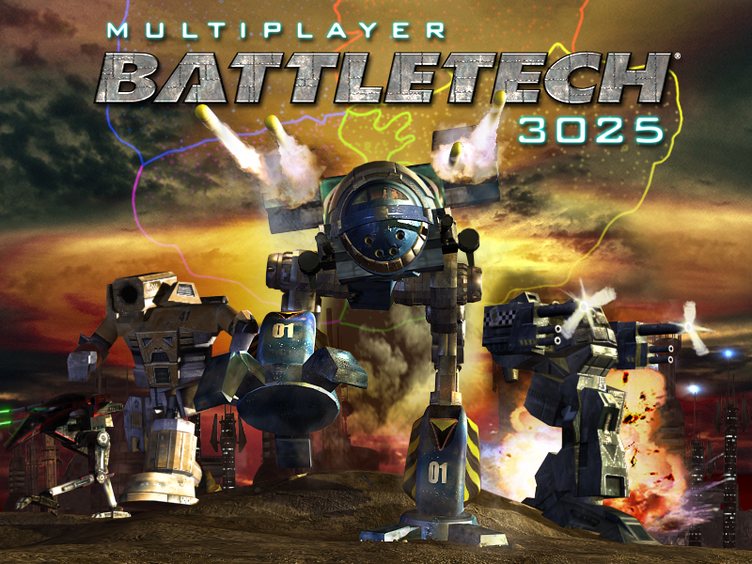

Player's Guide




Contents
Contents 2
Introduction 4
Installation 5
System Requirements 6
Getting Ready 7
Pilot Creation 7
Pilot Training 8
Planet Lobby 8
Enter Ready Room 10
Create Ready Room 10
Buy 'Mech 11
Chat 12
Ready Room 12
Select Seat 13
Select 'Mech 13
Ready 13
Observe 14
Buy 'Mech 14
Start Battle 14
Edit Room 15
Give Control 16
Exit Ready Room 16
Score, Rank & Levels 17
Scoring 17
Levels 18
Ranking 19
Combat 20
Basic Operations 20
Radio 21
Radar 21
Overhead View 21
Movement 21
Torso Twisting 22
Jumping 22
Joystick Controls 23
Mouse Controls 23
Keyboard Controls 24
Combat Controls 26
Targeting 26
Zoom 26
Firing Weapons 27
Weapon Groups 28
Ramming 28
Heat 29
Damage 29
Falling Down 30
Destruction 31
'Mechs 32
Individual 'Mechs 34
Weapons 41
Menu Bar 42
Game 42
My Pilot 42
View Pilot 43
Exit 43
Community 44
Contact List 44
Ignore List 44
Options 45
Video Options 45
Audio Options 47
Control Options 47
Word Filter 48
Complain 49
File Report 49
Page a Sysop 49
Help 50
Pilot Training 50
Credits 50
Credits 51
Copyright Notice 53

Introduction

Welcome to Multiplayer BattleTech:3025. In this online game, you pit your 'Mech piloting skills in head-to-head combat with up to seven other ranked pilots. You choose your own 'Mech, from a screaming fast Jenner to a ponderous but formidable Atlas class, from a personalized list that grows as you gain experience.

Different 'Mechs allow for widely different play styles. Some 'Mechs are fast but relatively unarmored, encouraging a dash-and-fire strategy. Other 'Mechs are massive and slow, but so well-armored and powerful that they don't need to run. Other factors, like balancing your fire rate against engine heat -- you can overwhelm an enemy with rapid fire, but risk overheating your 'Mech while doing so -- mean that every pilot develops a unique style, and every opponent you face will have surprises in store.

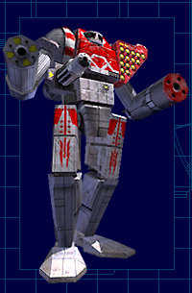

Installation

Before you can play Multiplayer BattleTech:3025, you must install it on your computer.

1. Go to http://www.ea.com. Select Multiplayer BattleTech:3025 from the menu on the left side of the page and click the Go! button.

2. Click Login. (If you do not already have an EA.com login, you need to click Subscribe and follow the instructions to create your member name.)

3. After you log into the game with your member name and password, click Play.

4. If you don't already have the EA.com Game Installer -- required to install any games from EA.com -- you'll be asked if you want it installed on your computer. Click Yes. You'll be prompted for the directory where it should be installed. Use the default directory, or choose your own, then click OK. The EA.com Game Installer will be set up on your system, and the installation of Multiplayer BattleTech:3025 will resume automatically.

5. You will be prompted for the directory where Multiplayer BattleTech:3025 should be installed on your computer. Use the default directory, or choose your own, and click OK.

6. The game will download and install. When the installation is complete, the game launches automatically.

System Requirements

Minimum Platform:
Pentium II 400MHz (or equivalent)
64MB of RAM
20-30MB free hard drive space
3D hardware accelerator with 16MB of RAM and nVidia TNT, 3dfx Voodoo 3, or equivalent functionality
28.8 Modem and Internet access
SoundBlaster or equivalent sound card
Keyboard and mouse

Recommended Platform:
Pentium III 500 MHz (or equivalent)
128MB of RAM
20-30MB free hard drive space
3D hardware accelerator with 32MB of RAM and nVidia GeForce 256 or equivalent functionality on AGP bus
56k Modem and Internet access
SoundBlaster or equivalent sound card
Joystick

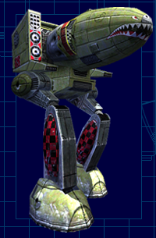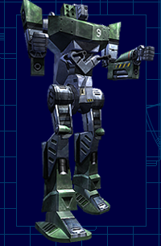

Getting Ready
This section describes the lobbies and interfaces you'll encounter when first entering Multiplayer BattleTech:3025, including pilot creation and training; the Planet Lobbies, where you'll meet and chat with other pilots; the Buy 'Mech screen, where you'll purchase new 'Mechs for combat; and the Ready Rooms, where you'll form teams and launch into battle.

Pilot Creation
The first time you log into Multiplayer Battletech:3025, you are sent to the Create Pilot screen. Enter your call sign, which is the name you wish to be known by in the game.

Next, choose which House you wish to be affiliated with. Use the arrows at either side of the Choose House field to view the five available Houses and their descriptions. When you find one you like, keep it in the Choose House line and click Done.

Veteran's Note:
MechWarriors are known for their colorful call signs... Wombat, Gray Eagle, Frizz, etc. Have fun with your call sign selection!

Davion | Kurita | Liao | Marik | Steiner
The Davions, ruling with the Federated Suns, have held a dominant position among the Successor States because they control more worlds than any other Great House. Prince Hanse Davion ushered in a new era of military strength as well as scientific advancement. | The Draconis Combine, under House Kurita, embraces bushido, the Japanese 'way of the warrior'. Of all the armies of the Inner Sphere, none is as universally feared and respected as House Kurita. | The Succession Wars saw the Capellan Confederation lose world after world. Now House Liao rules the smallest Successor States. Dedicated to recovering his lost empire, Maximillian Liao walks the divide between genius and madness. | The Free Worlds League clings to a representative form of governance long abandoned by the other Successor States. The ruling house, led by Janos Marik, spends as much time cajoling its own people as it does fighting the other Houses. | House Steiner rules the Lyran Commonwealth, a mercantile powerhouse second to none. Those merchant-princes lead a military juggernaut, but one riddled with political appointees and dilettantes.

Pilot Training
Pilot Training is a special single-player mode designed to teach you the basics of operating a BattleMech. You enter this mode automatically when you create a pilot, or you can access Pilot Training anytime by selecting it from the Help menu in the top menu bar.

You can either begin with the first lesson and progress through the entire training program, or pick only the lessons you wish. Click the right and left arrows in the Lesson Selector box to cycle through the three lessons; the description of each one appears in the box below. Click Begin Lesson to give the displayed lesson a try, or Done to leave training.

Lesson One | Lesson Two | Lesson Three
Communication basics  Using the Radar  Using the Bogie Indicator  Movement basics  Destroy Stationary Target | Torso Twisting  TIC Firing and Heat  TIC Configuration  Destroy Moving Target | Getting Up  Overheating  Jumping  Zoom  Destroy Moving Target

Once you click Begin Lesson, you will appear in a trainee's Spider class 'Mech. Your instructor will be nearby in a Catapult class 'Mech. Follow his instructions to progress through the lesson, or you can quit anytime by pressing the <esc> key.

Veteran's Note:
No, you cannot blow up your instructor .

Planet Lobby
Each planet in Multiplayer BattleTech:3025 has a Planet Lobby. In the lobby you can chat with other pilots, visit the Buy 'Mech screen, create a Ready Room (from which you'll enter combat), or enter someone else's Ready Room.

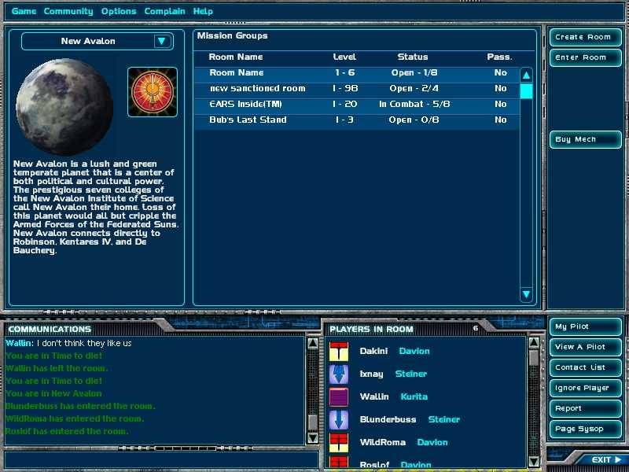

If you are a new pilot, you are placed in the lobby of a planet belonging to your House immediately after completing Pilot Training (or after creating your pilot if you elect to skip training.) If you have played before, you are placed in the Planet Lobby you used most recently. If that lobby is full, you are placed in another Planet Lobby belonging to your House.

To move to a different Planet Lobby, use the drop-down box above the picture of the planet you are on. You'll see a list of Houses: Davion, Kurita, Liao, Marik, and Steiner. Click on a House to display a list of planets belonging to that House, then click on a planet name to enter that Planet Lobby.

The bottom portion of the Planet Lobby is dedicated to chatting; read the section on Chat for information on its use. Buttons to the right of the chat window give you fast access to the Menu Bar functions of My Pilot, View a Pilot, Contact List, Ignore Player, Report, Page Sysop, and Exit.

Enter Ready Room
The large Mission Groups window in the Planet Lobby lists the available Ready Rooms for that Lobby. You'll see the room name, the required level range to enter, the room status (Open, Full, or In Combat, and the number of filled seats / total seats available) and whether the room is password protected.

To enter a Ready Room, highlight it and click Enter Room, or just double-click on the room name. If there is a seat available and you are within the required level range, you will appear in that Ready Room.

Create Ready Room

When you click Create Ready Room, a dialog appears asking for a name for your room and the maximum / minimum rank allowed for entry.
Veteran's Note:
If you like, you can enter a password so only your buddies can enter your room.

The Create Ready Room button is grayed out if the Planet Lobby already has its maximum number of Ready Rooms. You can either wait until a slot is available, or try a different lobby. Click OK to create the room and be placed inside it, or Cancel to change your mind and return to the lobby.

Buy 'Mech
Use the Buy 'Mech screen to review and purchase new 'Mechs, using Upgrade Points you earned by fighting battles.
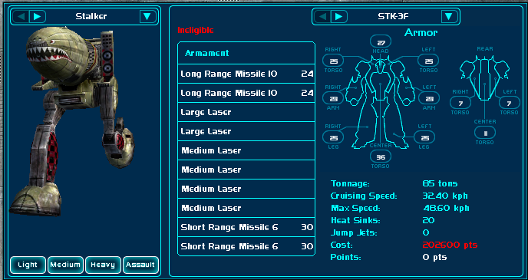

The picture on the far left of the screen depicts the currently selected 'Mech. Click a weight class button (Light, Medium, Heavy or Assault) under the picture to see the 'Mechs available in that class. Use the right and left arrows to cycle through the 'Mech types, or use the drop-down arrow to review the entire list.

Veteran's Note

When you're preparing to purchase a 'Mech, remember that each variant of a 'Mech type has its own cost.

Many types of 'Mechs have two or more variants in their design. The information bar in the top center of the screen displays which variant of the selected 'Mech type you are viewing. Change the variant with the right/left arrows, or display the entire list of possible variants using the drop-down arrow.

Next to the 'Mech illustration is a list of that 'Mech's available armaments, a chart illustrating the armor levels on the various parts of the 'Mech, and a list describing Tonnage, Cruising Speed, Max Speed, Heat Sinks, Jump Jets, Cost (in Upgrade Points) and Points (how many Upgrade Points you have available.)

When you've selected a 'Mech that you like (and can afford) click Buy 'Mech to add it to your collection. That 'Mech will be available from the Ready Room the next time you select a 'Mech for battle.

Chat
The Chat interface appears at the bottom of the Planet Lobby, the Buy 'Mech screen, and the Ready Rooms. Messages you type into the chat bar can be viewed by everyone in the room; if you want to send a private message, open the View Pilot dialog and click Message instead.

To chat, just click on the narrow chat bar at the bottom of the screen, type in your message, then hit the Enter key. Your message will appear in the large chat box above, and will be visible to everyone in the room.

Ready Room
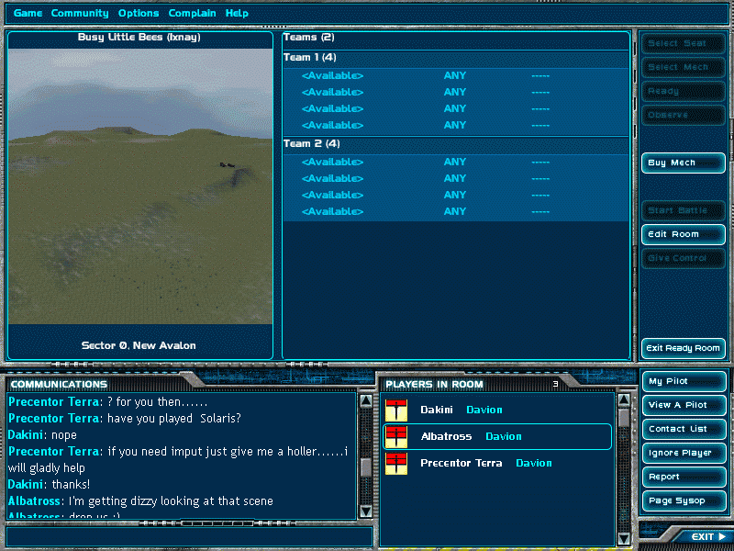

The Ready Room is used to gather teams of players together for battle. When you enter a Ready Room from a Planet Lobby, you are considered an observer (not a participant) until you Select a Seat, Select a 'Mech, and then indicate that you're Ready for battle.

If you are the room owner, meaning that either you created the Ready Room or had control transferred to you, additional controls are available to you alone. You can Start the Battle whenever you please. You can also Edit the room, or Give Control of the room to another player.

The bottom portion of the Ready Room screen is dedicated to chatting; read the section on Chat for information on its use. Chatting is useful in the Ready Room for choosing teams and getting to know your teammates and opponents.

Select Seat
The first thing to do when you enter the Ready Room for battle is to click on one of the available seats (not occupied by another pilot) and then click Select Seat. This puts you in that seat and activates the Select 'Mech option, which will begin to flash.

Select 'Mech
After selecting a seat, it's time to select which of your 'Mechs you will be using in this battle. Clicking Select 'Mech brings up a screen listing your available 'Mechs. (This screen resembles the Buy 'Mech screen, though you cannot purchase a 'Mech from here.) Pick one, then click Select 'Mech again. This finalizes your choice and activates the Ready button, which will begin to flash.

Veteran's Note:
If you want to purchase a new 'Mech at the last minute, you can visit the Buy 'Mech screen directly from the Ready Room by clicking Buy 'Mech.

Ready
When you've selected your seat and your 'Mech, click Ready to indicate that you're ready for battle. (If you change your mind, this button changes to a Not Ready button once clicked, so you can click it again to back out.)

Observe
If you've already chosen a seat and then decide that you'd rather just be an observer in this battle, not a participant, click Observe to leave your seat and remain in the Ready Room. You'll be able to watch the battle log, describing the major events of the battle, in the chat window once the battle begins.

Buy 'Mech
If you want to purchase a new 'Mech to use in this battle, click Buy 'Mech to access the Buy 'Mech screen directly from the Ready Room.

Start Battle
Only available to the Room Owner.

If all seats are filled and Ready, the battle starts automatically. If you want to start it sooner, clicking Start Battle anytime will start the battle, as long as at least two pilots are seated and Ready.

Veteran's Note:
Consider using the chat box to notify people if you're about to start a battle, so they can finish any last-minute adjustments before getting tossed onto the battlefield!

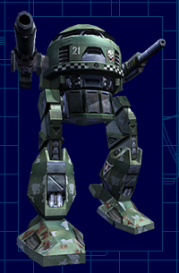

Edit Room
Only available to the Room Owner.

The Edit Room screen allows you to change Battle Maps, 'Mech weight class limits, and the number of pilots, teams, or seat configurations before the battle.

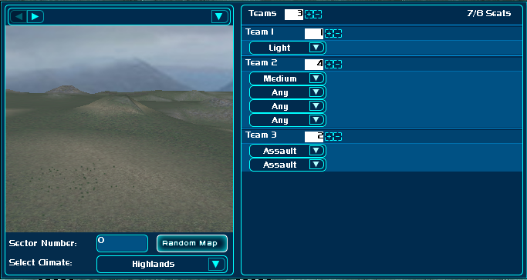

Each planet in Multiplayer BattleTech:3025 has its own collection of ten unique Battle Maps (with names such as the Disciples of Carnage Battlefield or Candyman's Charge) as well as access to randomly generated maps. To change Battle Maps, use the right and left arrows above the battlefield display to cycle through the available Maps, or use the drop-down arrow to view the entire list. Or, to randomly generate a map, click the Random Map button under the display. If you want a specific climate for your map, use the Select Climate drop-down arrow to choose from the list of available climates.

Use the [+] and [-] buttons over the Team display to adjust the total number of teams, and the same buttons next to each team name to change the number of seats on each team. You can have from 2-8 teams, each composed of 2-7 pilots, as long as you do not exceed 8 pilots total. For example, you could have:

- 2 teams of 4 pilots each (8 pilots total)
- 3 teams, one with 1 pilot, one with 2 pilots, and one with 4 pilots. (7 pilots total)
- 4 teams, two with 2 pilots each, and two with 1 pilot each (6 pilots total)
- 5 teams with 1 pilot each (5 pilots total)

If you're feeling brave, you can try:

- 2 teams, one with 7 pilots and one with 1 pilot (8 pilots total)

Or, if you just want to go head to head with a friend, you can try:

- 2 teams, each with 1 pilot (2 pilots total)

Finally, you can specify a 'Mech weight class limit (Light, Medium, Heavy or Assault) for each seat. Use the drop-down arrow in each column to select the class you want. The default is Any, which allows any class 'Mech to occupy that seat.

Click Done when you're finished, or Cancel to leave without saving any changes.

Give Control
Only available to the Room Owner.

To give control of the Ready Room to another pilot, click on that person's call sign and select Give Control. Once control is transferred, you'll be unable to access the special Room Owner functions unless control is transferred back to you.

Exit Ready Room
Anyone can leave the Ready Room at any time before the battle by clicking Exit.

Score, Rank & Levels
As you fight battles against other 'Mechs, you gain experience and eventually increase in level. With each level, you receive upgrade points that allow you to expand your selection of 'Mechs. (Go to the Buy 'Mech screen to trade upgrade points for 'Mechs.)

Scoring
Your score represents how much damage you inflicted on your opponents during combat. The major events that increase your score are: breaching an opponent's external armor (a body part turns red on your target display), blowing off an opponent's limb (an arm or leg turns black on your target display), and destroying another 'Mech. However, the exact number of points you gain is calculated by the battle-readiness of your target; the more damaged your target already is when you hit it, the fewer points you'll receive.

Veteran's Note:

Resist any temptation to shoot your teammates. Friendly fire results in heavy penalties to your score, as well as your team's overall score.

At the end of combat, you will also get to view your team's overall Team Score. Team score is calculated based on how much damage the team dealt out vs. how much damage the team took, with an additional bonus if your team won the battle. Even a losing team may receive points for a mission, depending on how much damage they inflicted before defeat.

Levels
In Multiplayer BattleTech:3025, you can achieve up to 99 levels by gaining points in combat. The following tables show how many points are required for each level promotion:

Level | Points
1 | 0
2 | 800
3 | 3200
4 | 7200
5 | 14200
6 | 23200
7 | 36400
8 | 52000
9 | 74400
10 | 101000
11 | 131800
12 | 166800
13 | 211600
14 | 262800
15 | 320400
16 | 386000
17 | 458000
18 | 548000
19 | 647000
20 | 756800
21 | 875600
22 | 1021600
23 | 1179600
24 | 1366600
25 | 1569000
26 | 1806600
27 | 2063400
28 | 2339400
29 | 2634600
30 | 2975200
31 | 3315800
32 | 3656400
33 | 3997000

Level | Points
34 | 4337600
35 | 4678200
36 | 5018800
37 | 5359400
38 | 5700000
39 | 6040600
40 | 6381200
41 | 6721800
42 | 7062400
43 | 7403000
44 | 7743600
45 | 8084200
46 | 8424800
47 | 8765400
48 | 9106000
49 | 9446600
50 | 9787200
51 | 10127800
52 | 10468400
53 | 10809000
54 | 11149600
55 | 11490200
56 | 11830800
57 | 12171400
58 | 12512000
59 | 12852600
60 | 13193200
61 | 13533800
62 | 13874400
63 | 14215000
64 | 14555600
65 | 14896200
66 | 15236800

Level | Points
67 | 15577400
68 | 15918000
69 | 16258600
70 | 16599200
71 | 16939800
72 | 17280400
73 | 17621000
74 | 17961600
75 | 18302200
76 | 18642800
77 | 18983400
78 | 19324000
79 | 19664600
80 | 20005200
81 | 20345800
82 | 20686400
83 | 21027000
84 | 21367600
85 | 21708200
86 | 22048800
87 | 22389400
88 | 22730000
89 | 23070600
90 | 23411200
91 | 23751800
92 | 24092400
93 | 24433000
94 | 24773600
95 | 25114200
96 | 25454800
97 | 25795400
98 | 26136000
99 | 26476600

Ranking
Each of the five Houses have nine ranks associated with levels 1-30 (your rank remains the same for levels over 30.) Each rank for each House has a unique name and icon.

Level | Davion | Kurita | Laio | Marik | Steiner
1 | Private | Heishi | Recruit | Private | Private
2-4 | Corporal | Go-cho | Lance Corporal | Corporal | Corporal
5-7 | Sergeant | Gunsho | Lance Sergeant | Sergeant | Sergeant
8-10 | Sergeant-Major | Sho-ko | Asst. Force Leader | Sergeant Major | Sergeant Major
11-15 | Leftenant | Chu-I | Force Leader | Lieutenant | Leutnant
16-20 | Captain | Tai-I | Captain | Captain | Hauptmann
21-25 | Major | Sho-Sa | Major | Force Commander | Kommandant
26-29 | Leftenant Colonel | Chu-Sa | Senior Major | Lieutenant Colonel | Leutnant Colonel
30 | Colonel | Tai-sa | Regimental Colonel | Colonel | Colonel

Combat
When you are launched into battle from a Ready Room, the look of the game changes. You appear on the battlefield, in your 'Mech's cockpit. The terrain stretches before you, and around the edges of your screen are various status indicators that comprise the HUD (Heads Up Display). For the next fifteen minutes (or less, if the battle resolves sooner) your sole mission is to pilot your 'Mech, blow away your opponents, and keep from getting blown away yourself.

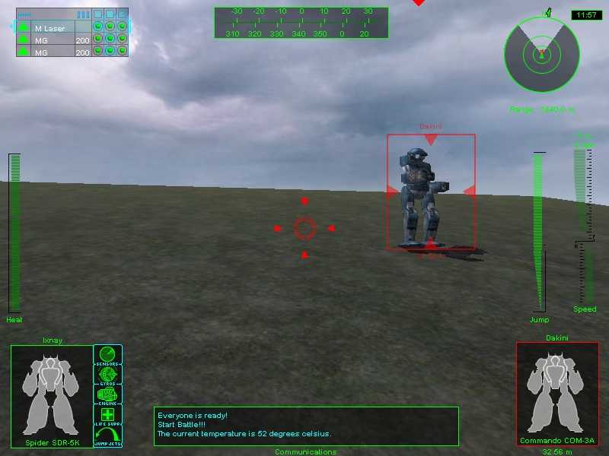

Basic Operations
Before you rush into battle, make sure you're familiar with the basic operations of your 'Mech: the radio, radar, and overhead view, the movement and speed controls, torso twisting and jumping, along with the joystick, mouse or keyboard controls you'll need to survive.

Radio
Communicating with other pilots during battle is crucial. You will want to coordinate strategies with members of your team, call for help, and also to taunt and demoralize your opponents.

To use your radio to send a message to everyone on the battlefield, press TAB, then type your message. Use Shift-TAB to send a message only to your own team.

Radar
The radar display in the upper right corner of the HUD (Heads Up Display) shows your position relative to all other 'Mechs in the battle. Your 'Mech is always in the center of the radar display; the clear wedge on the radar indicates your line of sight. 'Mechs on your team will be green on the display. All other 'Mechs will be red.

The Insert key zooms the radar in for a closer view; the Delete key zooms it out. (You can configure your joystick to perform the radar zoom functions by going to the Control Options screen.)

Overhead View
If you want a broader view of the battlefield, press M on the keyboard for an overhead view. You can scroll the overhead view with the keyboard's arrow keys. (To change these default keys, go to the Control Options screen.)

Movement
You can move and turn your 'Mech using the keyboard or joystick; go to the Control Options screen to customize these controls. The default movement controls are:

- Keypad 8 Move forward
- Keypad 5 Stop
- Keypad 2 Move backward
- Keypad 4 Turn left
- Keypad 6 Turn right

The speedometer on the right edge of your HUD shows your current speed, either forward or backward. Different 'Mechs have different top speeds; heavily armored 'Mechs, or 'Mechs loaded down with many weapons, move more slowly than their leaner counterparts. Adjust your strategies accordingly.

Veteran's Note:
Remember, the faster you're moving, the longer it takes to turn!

Torso Twisting
You can rotate the top torso of your 'Mech independently of your legs, up to 45 degrees either right or left, giving you a full 90 degree forward arc. You can also tilt your torso up and down.

The Heading Bar at the top center of your screen gives information about the direction your torso is twisted, as well as your overall heading. The top half of the bar shows the number of degrees you are twisted; the bottom half of the bar shows your overall compass heading, in numeric form (0 indicates true north.)

You can twist and tilt your torso using the keyboard, joystick or mouse; visit the Control Options screen to configure the controls. Re-center your torso anytime by pressing C.

Jumping
Some 'Mechs are equipped with jump jets, which enable you to briefly take to the air. The Jump Fuel Meter, on the right side of your HUD next to your speedometer, indicates the duration of your jump; when the bar turns red, you're on your way back to the ground. This meter doesn't appear if your 'Mech is not equipped with jump jets.

To jump, press J on the keyboard. Once you are airborne, use the right and left arrow keys to maneuver right and left. The down arrow makes you go higher, and the up arrow gives you forward thrust. (Go to the Control Options screen if you want to configure your joystick to control your jumps instead.) Naturally, these commands won't work if your 'Mech is not equipped with jump jets, or if your jump jets have been destroyed.

Joystick Controls
Multiplayer Battletech:3025 is fully playable by joystick. Because joystick configurations are so varied, you will need to custom-configure most of the controls by opening the Options menu in the menu bar across the top of your screen and then selecting Control Options.

The default joystick controls are listed below.

Default Joystick Controls
Joystick 1 | Fire current weapon
Joystick 2 | Select crosshair target
Joystick 3 | Select next TIC as firing TIC
Joystick 4 | Fire currently selected TIC

Mouse Controls
The default mouse controls are listed below. If you want to change the mouse controls, open the Options menu from the bar across the top of your screen, then select Control Options.

Default Mouse Controls
LMB | Fire Selected Weapon / Zoom in tactical view
ALT LMB | Grab and drag HUD component
RMB | Fire Selected TIC / Zoom out in tactical view
RMB | Zoom out in tactical view
Mouse/ARROW | Scroll map in tactical view

Keyboard Controls
The default keyboard controls are listed below. If you want to change the keyboard controls, open the Options menu from the bar across the top of your screen, then select Control Options.

Default Keyboard Controls
Twist torso left | A / Mouse
Twist torso right | D / Mouse
Tilt torso up | W / Mouse
Tilt torso down | S / Mouse
Center torso | C
Turn 'Mech left | Numpad 4
Turn 'Mech right | Numpad 6
Jump | J
Eject | Esc
Stand Up | G
Select weapon in slot 1 - 10 | 1 - 0
Select next weapon in the list | Numpad +
Select previous weapon in the list | Numpad -
Fire current weapon | Space / LMB
Toggle TIC 'A' on current weapon | L
Toggle TIC 'B' on current weapon | ;
Toggle TIC 'C' on current weapon | '
Select TIC 'A' as current firing TIC | P
Select TIC 'B' as current firing TIC | [
Select TIC 'C' as current firing TIC | ]
Select next TIC as firing TIC | Numpad 0
Select previous TIC as firing TIC | Numpad .
Set throttle to 0 | Numpad 5
Increase throttle | Numpad 8
Decrease throttle | Numpad 2
Fire weapon in TIC 'A' | NUM LOCK
Fire weapon in TIC 'B' | Numpad /
Fire weapon in TIC 'C' | Numpad *
Fire currently selected TIC | X / RMB
Toggle help screen on/off | F1
Toggle self info on/off | U
Toggle the size of the chat window | ~
Toggle the tactical map on/off | M
Zoom the radar in | Insert
Zoom the radar out | Delete
Toggle 'mouse look' on/off | BACKSPACE
Send a chat message to your team | Shift-TAB
Send a chat message to everyone | TAB
Select friendly target | Shift-Enter
Select enemy target | Numpad-Enter
Select crosshair target | Enter
File a complaint | Alt and F11
Toggle visible on HUD element 1 - 11 | Shift and 1-0 + ~
Cycle player damage display | Numpad 1
Cycle target damage display | Numpad 3
Cycle the targeting reticle | F2
Reset HUD | F3
Toggle 'sticky' view on/off | End
Move in left view | Left Arrow
Move to right view | Right Arrow
Move to up view | PgUp
Move to down view | PgDn
Move to forward view | Up Arrow
Move to backward view | Down Arrow
Set zoom level to 0% | .
Increase zoom level | =
Decrease zoom level | -
Set zoom level to 50% | /
Set zoom level to 100% | ,
Go to external view | F10
Screen capture | F11
Toggle frame rate | F

Combat Controls
The time has come. You've created your pilot, picked your 'Mech, found at least one opponent, and now you're ready to inflict some damage. This section covers targeting your enemy, how to zoom your view, firing your weapons and using weapon groups, ramming another 'Mech, heat and overheating, taking damage, what to do if you fall down, and what happens if your 'Mech is destroyed.

Targeting
The first step toward destroying an opponent 'Mech is to target it with your scanner. When an opponent is within range and in your line of sight, press Enter to target. (You can configure your joystick to perform this function in the Control Options screen.)

When you target another 'Mech, an indicator box appears around that 'Mech on your screen. When your target is in range of your currently selected weapon, arrows appear around the perimeter of the box.

The Target Display box appears in the lower right corner of the screen when a 'Mech is targeted. The Target Display box displays a diagram of your target, showing the damage levels of his various systems:

Damage Display
White | Undamaged
Green | Lightly damaged
Yellow | Heavy damaged
Red | Armor has been penetrated
Black | Component is destroyed (black chest or head indicates total destruction.)

Zoom
You can use the Zoom function to zoom your view, helping you see what's going on in the distance, or to target a long-range opponent. The = and - keys on your keyboard increase and decrease zoom incrementally. The , (comma) key increases zoom magnification to maximum, / is one-half zoom, and . (period) returns your view to normal.

Firing Weapons
Your 'Mech's weapon list appears in a box at the upper left corner of your HUD. This box displays important status information about each weapon.

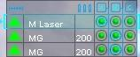

The first icon in each row is the range indicator; a green arrow confirms that the target is within the weapon's range. The weapon name follows. Next is the ammo indicator; if the weapon requires ammo, ammo remaining is displayed here. Last is the firing status display; a hollow circle means that the weapon is recharging and cannot be fired, and a solid green circle indicates that the weapon is ready to fire. The TIC control is also part of this firing status display (see the section on Weapon Groups for more information.)

At the start of the battle, the first weapon in the box is automatically highlighted. Every time you fire a weapon, the next weapon on the list will be highlighted in turn, enabling you to rapid-fire your weapons by hitting the spacebar repeatedly. (The left mouse button also fires your weapon.) To select a different weapon, type its corresponding number (1-0) on the keyboard.

The reticle, or crosshair, in the center of your HUD indicates where your weapons will strike. Once you have an opponent centered in the reticle, you are ready to fire! Check to confirm that your target is within range (a green arrow next to your selected weapon) and that the weapon is ready (a solid green dot), then press the spacebar.

Veteran's Note:
If your target is properly lined up when you fire a weapon, you automatically achieve a target lock. This means that your missiles and ballistic weapons will hit even if your target moves while you're firing... although missiles are less precise about exactly where on your opponent they'll strike.

Weapon Groups
For more advanced players, one way to victory is to fire multiple weapons at the same target simultaneously, which can be achieved with weapon grouping.

Veteran's note:
Beware! If you fire all your weapons at once, they might all miss at once. If that happens, you'll have no available weapons until they recharge.
You need to select, on a weapon-by-weapon basis, which weapon group, or TIC, each weapon is assigned to. The default keyboard controls for this are: the L key to assign a weapon to TIC A, the ; key for TIC B, and the ' key for TIC C. The weapon is assigned if its green status light has a white outline around it under that TIC listing.

You can also assign weapons using the mouse. Press the BACKSPACE key to activate the mouse cursor. To add a weapon to a TIC group, click the green dot from that weapon's row in the column of the desired group. A white outline will appear around the dot, confirming your selection. When you are finished, press BACKSPACE again to remove the mouse cursor.

There are two ways to fire weapon groups. The first is to simply press the keyboard key assigned to that TIC: the defaults are the NUM LOCK key to fire group A, Numpad / to fire group B, or Numpad * to fire group C. The second way is to select the TIC first, using the P, [ or ] keys, then press the X key (or use the right mouse button) to fire the selected group when you're ready.

Ramming
Besides firing your weapons, the only other way to damage your opponent is by ramming. Simply aim for another 'Mech and accelerate! The amount of damage done to each 'Mech is determined by tonnage and velocity.

Veteran's Note:
Pilots of smaller, lighter 'Mechs are advised to consider carefully before attempting to ram big, heavy 'Mech types. The effect could be similar to slamming a cookie against a solid wall.

Heat
Always remember to monitor the heat of your 'Mech. Heat is generated by movement (greater speed generates greater heat) and by firing your weapons. High heat levels cause movement penalties and, eventually, the overheating and automatic shutdown of your 'Mech.

Your heat level is always visible on the Heat Meter on the left side of the HUD.

If your 'Mech overheats, all systems automatically power down. You will be unable to control your 'Mech until your Heat Meter returns to yellow.
Veteran's Note:
If your heat alarm goes off, take immediate measures to prevent overheating. Slow down, and stop firing weapons for a moment or two. Chances are, you'll take less damage that way than you would if your 'Mech overheats.

Damage
When hit by enemy fire, the first damage you receive is to your external armor. External damage does not affect the functioning of your 'Mech, but once that armor is gone, attacks begin to affect your internal armor. There is also a chance of an enemy achieving a critical hit on your internal armor, destroying the system the armor protected. If the internal armor of any of your systems is destroyed, the effect varies:

Location | Effect
Head | 'Mech destroyed
Center torso | 'Mech destroyed
Left torso | Left arm blown off
Right torso | Right arm blown off
Left arm | None
Right arm | None
Left leg | 'Mech begins limping  (movement impeded)

Location | Effect
Right leg | 'Mech begins limping  (movement impeded)
Sensors | Weapon fire disabled
Gyros | 'Mech unable to stand
Engine | 'Mech destroyed
Life Support | 'Mech destroyed
Jump Jets | 'Mech unable to jump

Monitor your damage levels in the Damage Display in the bottom left corner of your HUD. This display shows the front and back of your 'Mech, along with a row of boxes showing the state of your sensors, gyros, engine, life support and jump jets, if you have them.

The colors used on the display indicate various levels of damage:

Damage Display
White | Undamaged
Green | Light external damage
Yellow | Heavy external damage
Red | Internal damage
Black | Component is destroyed

Falling Down
Falling down is extremely dangerous. You will be unable to defend yourself until you get your 'Mech back on its feet. You may fall down if you take damage to one of your hips, legs or feet; if you take gyro damage; or if you overheat while in the air.

Veteran's Note:
You will also fall down if your 'Mech is destroyed, but in this case, you will not be able to stand up again.

The default keyboard control for standing up is G. You can change this key, or configure your joystick to this function, in the Control Options screen.

Destruction
If your 'Mech is destroyed, there is no way to recover -- you are done for the rest of that combat. However, you can still observe the rest of the battle as a 'ghost' by using your movement controls to tour the battlefield. You can also use the Return key to display the cockpit view of the closest 'Mech to your position. Clicking Return repeatedly moves you from 'Mech to 'Mech.

If you'd rather not watch, hit <esc> to return to the Post-Battle Ready Room, where you can watch battle updates as they happen. When the battle completes, you can review the final battle log and your score for as long as you wish; click Continue when you're ready to return to the regular Ready Room functions.

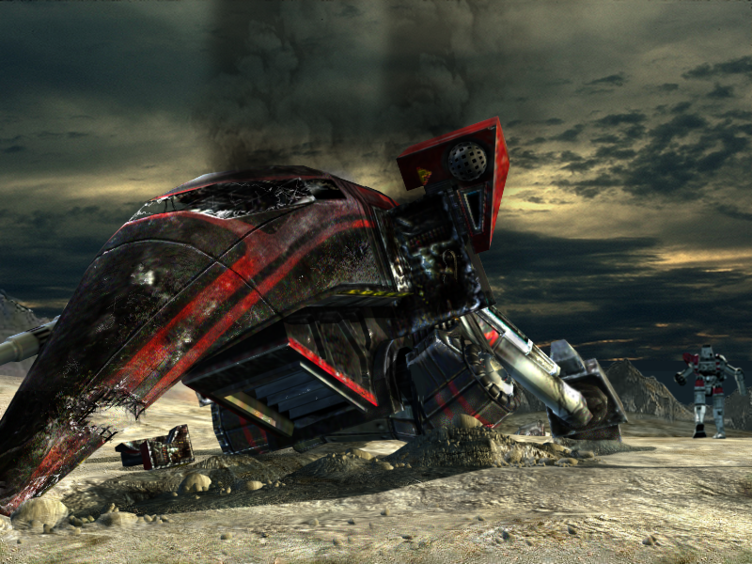

'Mechs
BattleMechs, called 'Mechs, are the huge robotic vehicles piloted by MechWarriors. 'Mechs are available in four weight classes:

Light 20-35 tons
Medium 40-55 tons
Heavy 60-75 tons
Assault 80-100 tons

The following tables list the 'Mechs and 'Mech variants available in Multiplayer BattleTech:3025:

Light 'Mechs
Name | Variants
Commando | COM-2D  COM-3A
Javelin | JVN-10F  JVN-10N
Spider | SDR-5D  SDR-5K  SDR-5V
UrbanMech | UM-R60  UM-R60L
Jenner | JR7-D  JR7-F
Panther | PNT-9R
Raven | RVN-1X
Assassin | ASN-101  ASN-21

Medium 'Mechs
Name | Variants
Cicada | CDA-2A  CDA-2B  CDA-3Cs
Vulcan | VL-2T  VL-5T
Blackjack | BJ-1  BJ-1DB  BJ-1DC
Centurion | CN9-A  CN9-AH  CN9-AL  CN9-YLW
Enforcer | ENF-4R
Hunchback | HBK-4G  HBK-4H  HBK-4J  HBK-4N  HBK-4P  HBK-4SP
Trebuchet | TBT-5J  TBT-5N  TBT-5S  TBT-7K

Heavy 'Mechs
Name | Variants
Quickdraw | QKD-4G  QKD-4H  QKD-5A
Catapult | CPLT-A1  CPLT-C1  CPLT-C4  CPLT-K2
JagerMech | JM6-A  JM6-S
Grasshopper | GHR-5H
Orion | ON1-K  ON1-V  ON1-VA

Assault 'Mechs
Name | Variants
Stalker | STK-3F  STK-3H  STK-4N
Banshee | BNC-3E  BNC-3M  BNC-3Q  BNC-3S
Atlas | AS7-D

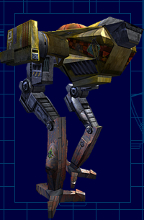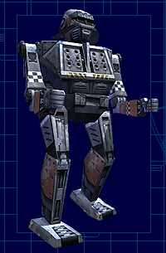

Individual 'Mechs

Want the details? Following, in alphabetical order, are descriptions of all the 'Mechs available in Multiplayer BattleTech:3025.

Assassin ASN-101
Class: Medium
Armor Tonnage: 67
Heat Sinks: 10
Jump Jets: 5
ML
3xSL
SRM2(50)
LRM5(24)

Assassin ASN-21
Class: Medium
Armor Tonnage: 76
Heat Sinks: 10
Jump Jets: 7
ML
SRM2(50)
LRM5(24)

Atlas AS7-D
Class: Assault
Armor Tonnage: 275
Heat Sinks: 20
Jump Jets: 0
AC20(10)
LRM20(12)
SRM6(15)
2xML
2xML*

Banshee BNC-3E
Class: Assault
Armor Tonnage: 218
Heat Sinks: 16
Jump Jets: 0
PPC
AC5(20)
SL

Banshee BNC-3M
Class: Assault
Armor Tonnage: 218
Heat Sinks: 16
Jump Jets: 0
2xPPC
2xML
SL

Banshee BNC-3Q
Class: Assault
Armor Tonnage: 218
Heat Sinks: 12
Jump Jets: 0
AC20(30)
SL

Banshee BNC-3S
Class: Assault
Armor Tonnage: 218
Heat Sinks: 21
Jump Jets: 0
2xPPC
AC10(20)
SRM6(15)
4xML
2xSL

Blackjack BJ-1
Class: Medium
Armor Tonnage: 136
Heat Sinks: 11
Jump Jets: 4
2xAC2(45)
4xML

Blackjack BJ-1DB
Class: Medium
Armor Tonnage: 122
Heat Sinks: 17
Jump Jets: 4
2xLL
2xML

Blackjack BJ-1DC
Class: Medium
Armor Tonnage: 136
Heat Sinks: 12
Jump Jets: 0
2xAC2(45)
4xML
2xSL

Catapult CPLT-A1
Class: Heavy
Armor Tonnage: 186
Heat Sinks: 15
Jump Jets: 4
2xLRM15(32)

Catapult CPLT-C1
Class: Heavy
Armor Tonnage: 154
Heat Sinks: 15
Jump Jets: 4
2xLRM15(16)
4xML

Catapult CPLT-C4
Class: Heavy
Armor Tonnage: 154
Heat Sinks: 10
Jump Jets: 4
2xLRM20(24)
2xSL

Catapult CPLT-K2
Class: Heavy
Armor Tonnage: 170
Heat Sinks: 20
Jump Jets: 0
2xPPC
2xML
2xMG(200)

Centurion CN9-A
Class: Medium
Armor Tonnage: 136
Heat Sinks: 10
Jump Jets: 0
AC10(20)
ML
LRM10(24)
ML*

Centurion CN9-AH
Class: Medium
Armor Tonnage: 136
Heat Sinks: 10
Jump Jets: 0
AC20(10)
LRM10(24)

Centurion CN9-AL
Class: Medium
Armor Tonnage: 164
Heat Sinks: 16
Jump Jets: 0
LL
ML
SL
LRM10(24)
ML*

Centurion CN9-YLW
Class: Medium
Armor Tonnage: 138
Heat Sinks: 10
Jump Jets: 0
ML
AC20(15)
ML*

Cicada CDA-2A
Class: Medium
Armor Tonnage: 71
Heat Sinks: 10
Jump Jets: 0
2xML
SL

Cicada CDA-2B
Class: Medium
Armor Tonnage: 62
Heat Sinks: 10
Jump Jets: 0
2xML
FL

Cicada CDA-3C
Class: Medium
Armor Tonnage: 71
Heat Sinks: 11
Jump Jets: 0
PPC
2xMG(200)

Commando COM-2D
Class: Light
Armor Tonnage: 68
Heat Sinks: 10
Jump Jets: 0
ML
SRM6(15)
SRM4(25)

Commando COM-3A
Class: Light
Armor Tonnage: 50
Heat Sinks: 10
Jump Jets: 0
ML
2xSRM6(15)
FL

Enforcer ENF-4R
Class: Medium
Armor Tonnage: 139
Heat Sinks: 12
Jump Jets: 4
AC10(10)
LL
SL

Grasshopper GHR-5H
Class: Heavy
Armor Tonnage: 196
Heat Sinks: 22
Jump Jets: 4
LL
4xML
LRM5(24)

Hunchback HBK-4G
Class: Medium
Armor Tonnage: 152
Heat Sinks: 13
Jump Jets: 0
AC20(10)
2xML
SL

Hunchback HBK-4H
Class: Medium
Armor Tonnage: 152
Heat Sinks: 13
Jump Jets: 0
AC10(20)
4xML
SL

Hunchback HBK-4J
Class: Medium
Armor Tonnage: 152
Heat Sinks: 14
Jump Jets: 0
5xML
SL
2xLRM10(24)

Hunchback HBK-4N
Class: Medium
Armor Tonnage: 152
Heat Sinks: 13
Jump Jets: 0
AC5(20)
4xML
SL
2xLRM5(24)

Hunchback HBK-4P
Class: Medium
Armor Tonnage: 152
Heat Sinks: 23
Jump Jets: 0
8xML
SL

Hunchback HBK-4SP
Class: Medium
Armor Tonnage: 152
Heat Sinks: 19
Jump Jets: 0
4xML
SL
2xSRM6(30)

JagerMech JM6-A
Class: Heavy
Armor Tonnage: 126
Heat Sinks: 10
Jump Jets: 0
2xAC2(45)
2xLRM15(16)
2xML

JagerMech JM6-S
Class: Heavy
Armor Tonnage: 98
Heat Sinks: 10
Jump Jets: 0
2xAC5(40)
2xAC2(45)
2xML

Javelin JVN-10F
Class: Light
Armor Tonnage: 95
Heat Sinks: 12
Jump Jets: 6
4xML

Javelin JVN-10N
Class: Light
Armor Tonnage: 68
Heat Sinks: 10
Jump Jets: 6
2xSRM6(30)

Jenner JR7-D
Class: Light
Armor Tonnage: 68
Heat Sinks: 10
Jump Jets: 5
4xML
SRM4(25)

Jenner JR7-F
Class: Light
Armor Tonnage: 111
Heat Sinks: 10
Jump Jets: 5
4xML

Orion ON1-K
Class: Heavy
Armor Tonnage: 213
Heat Sinks: 10
Jump Jets: 0
AC10(20)
LRM15(16)
SRM4(25)
2xML

Orion ON1-V
Class: Heavy
Armor Tonnage: 170
Heat Sinks: 10
Jump Jets: 0
AC10(20)
LRM15(16)
2xSRM4(50)
2xML

Orion ON1-VA
Class: Heavy
Armor Tonnage: 213
Heat Sinks: 16
Jump Jets: 0
AC10(20)
2xSRM4(50)
2xML

Panther PNT-9R
Class: Light
Armor Tonnage: 108
Heat Sinks: 13
Jump Jets: 4
PPC
SRM4(25)

Quickdraw QKD-4G
Class: Heavy
Armor Tonnage: 129
Heat Sinks: 13
Jump Jets: 5
2xML
LRM10(12)
SRM4(25)
2xML*

Quickdraw QKD-4H
Class: Heavy
Armor Tonnage: 129
Heat Sinks: 13
Jump Jets: 5
4xML
LRM10(12)
SRM4*(25)

Quickdraw QKD-5A
Class: Heavy
Armor Tonnage: 129
Heat Sinks: 17
Jump Jets: 5
SRM4(25)
4xML
2xML*

Raven RVN-1X
Class: Light
Armor Tonnage: 68
Heat Sinks: 12
Jump Jets: 0
2xML
SRM6(15)

Spider SDR-5D
Class: Light
Armor Tonnage: 60
Heat Sinks: 10
Jump Jets: 8
ML
FL

Spider SDR-5K
Class: Light
Armor Tonnage: 60
Heat Sinks: 10
Jump Jets: 6
ML
2xMG(200)

Spider SDR-5V
Class: Light
Armor Tonnage: 60
Heat Sinks: 10
Jump Jets: 8
2xML

Stalker STK-3F
Class: Assault
Armor Tonnage: 198
Heat Sinks: 20
Jump Jets: 0
2xLL
4xML
2xLRM10(24)
2xSRM6(30)

Stalker STK-3H
Class: Assault
Armor Tonnage: 198
Heat Sinks: 20
Jump Jets: 0
2xLRM20(12)
2xSRM6(30)
4xML

Stalker STK-4N
Class: Assault
Armor Tonnage: 198
Heat Sinks: 26
Jump Jets: 0
2xLL
4xML
LRM10(12)
2xSRM6(30)

Trebuchet TBT-5J
Class: Medium
Armor Tonnage: 124
Heat Sinks: 15
Jump Jets: 5
3xML
LRM15(8)

Trebuchet TBT-5N
Class: Medium
Armor Tonnage: 116
Heat Sinks: 10
Jump Jets: 0
3xML
2xLRM15(16)

Trebuchet TBT-5S
Class: Medium
Armor Tonnage: 116
Heat Sinks: 18
Jump Jets: 0
3xML
2xSRM6(30)

Trebuchet TBT-7K
Class: Medium
Armor Tonnage: 116
Heat Sinks: 11
Jump Jets: 0
PPC
AC5(20)
SRM2(50)

UrbanMech

UM-R60
Class: Light
Armor Tonnage: 103
Heat Sinks: 11
Jump Jets: 2
AC10(10)
SL

UrbanMech

UM-R60L
Class: Light
Armor Tonnage: 68
Heat Sinks: 11
Jump Jets: 2
AC20(5)
SL

Vindicator VND-1AA
Class: Medium
Armor Tonnage: 74
Heat Sinks: 16
Jump Jets: 5
PPC
ML
SL
LRM5(24)

Vindicator VND-1R
Class: Medium
Armor Tonnage: 144
Heat Sinks: 16
Jump Jets: 4
PPC
ML
SL
LRM5(24)

Vulcan VL-2T
Class: Medium
Armor Tonnage: 86
Heat Sinks: 10
Jump Jets: 6
AC2(45)
ML
FL
MG(200)

Vulcan VL-5T
Class: Medium
Armor Tonnage: 115
Heat Sinks: 12
Jump Jets: 6
4xML
FL
MG(200)

Weapons

The three major weapon types in Multiplayer BattleTech:3025 are energy-based, ballistic, and missiles. Energy weapons are powered by your 'Mech's engine, and never run out. Ballistic weapons require ammo, which is carried by the ton. Missiles are fired individually until your stock is depleted.

Veteran's Note:
Ammunition is flammable! Your supply of missiles or ammo can explode if hit in combat, causing massive damage to your 'Mech.

Ammo is allocated by weapon type, not by individual weapon. For example, if your 'Mech is equipped with four Autocannon 5's, none of them will fire when you run out of that ammo type.

Name the weapon's name
Heat the amount of heat the weapon generates when fired
Damage the amount of damage the weapon does on contact
Impact the jarring effect of being hit by this weapon
Delay how many seconds you must wait between shots
Range the weapon's combat range in meters (hits beyond this range cause no damage)
Ammo the number of shots available per ton of ammunition (- indicates an energy-based weapon)

Weapon Name | Heat | Damage | Impact | Delay | Range | Ammo
Flamer | 12 | 2 | 5 | 2 | 90 | -
Small Laser (S. Laser) | 4 | 3 | 5 | 2 | 90 | -
Medium Laser (M. Laser) | 12 | 5 | 20 | 2 | 270 | -
Large Laser (L. Laser) | 32 | 8 | 50 | 3 | 450 | -
Particle Projection Cannon (PPC) | 40 | 10 | 75 | 4 | 540 | -
Machine Gun (MG) | 0 | 2 | 5 | 1 | 90 | 200
Autocannon 2 (AC2) | 4 | 2 | 10 | 1 | 720 | 45
Autocannnon 5 (AC5) | 4 | 5 | 30 | 2 | 540 | 20
Autocannon 10 (AC10) | 12 | 10 | 75 | 2 | 450 | 10
Autocannon 20 (AC20) | 28 | 20 | 100 | 3 | 270 | 5
Short Range Missile 2 (SRM2) | 8 | 2 | 10 | 2 | 270 | 50
Short Range Missile 4 (SRM4) | 12 | 2 | 15 | 2 | 270 | 25
Short Range Missile 6 (SRM6) | 16 | 2 | 25 | 2 | 270 | 15
Long Range Missile 5 (LRM5) | 8 | 1 | 10 | 3 | 630 | 24
Long Range Missile 10 (LRM10) | 16 | 1 | 30 | 3 | 630 | 12
Long Range Missile 15 (LRM15) | 20 | 1 | 60 | 3 | 630 | 8
Long Range Missile 20 (LRM20) | 28 | 1 | 90 | 3 | 630 | 6

Menu Bar

The Menu Bar along the top of the non-combat screens -- called the top menu bar -- offers a variety of ways to interact with the game, communicate with your friends, manage your options, and get help in Multiplayer Battletech:3025. The categories along the bar are:

Game | Community | Options | Complain | Help
My Pilot  View Pilot  Exit | Flash Message  Ignore List | Video  Audio  Controls  Word Filter | Report  Page Sysop | Pilot Training  Credits

Game
Use this menu to access the My Pilot interface, the View Pilot interface, or to Exit the game.

My Pilot
Selecting My Pilot brings up a dialog displaying your call sign, level, total score, 'Mech points, total number of wins, total number of losses, and win percentage. You can also use this dialog to change your House allegiance, or to create a new character.

To change Houses, click Change House, select the House you want to join, then click Done. You can only change Houses once every 24 hours.

To create a new character, click New Character, then enter your new call sign and choose a House. Click Done when you are finished. Warning: choosing this option will reset your character, permanently erasing your score and any 'Mechs you currently own. Once reset, these things cannot be returned to you.

You can also bring up this dialog by clicking My Pilot at the right side of the Chat interface, or by double-clicking your Pilot name.

View Pilot
View Pilot gives you similar information as My Pilot (call sign, level, score, total number of wins, total number of losses, and win percentage) for any pilot; just type their name in the box and click View. You can also use the drop-down menu to view the names of the pilots on your Contact List; highlight one, then click View.

On the right side of the View Pilot dialog is a row of buttons leading to various functions. The join button moves yourself to that pilot's location, if possible. Remove Contact removes that pilot from your Contact list. Message opens a dialog to send an instant message to that pilot; enter your message in the lower box, then press the Enter key. Ignore Player adds that pilot to your Ignore List.

You can select from these to bring up the appropriate dialog, or click Close when you're finished.

You can also bring up this dialog by right-clicking on a player list window in any Planet Lobby or Ready Room, or by double-clicking on any pilot's name.

Exit
Ready to leave? Selecting Exit brings up a confirmation screen; if you're really sure, click Ok to leave the game. All your latest character information (score, wins, losses, etc.) will be automatically saved for the next time you play.

You can also exit by clicking Exit in the lowest right corner of the Chat interface in any Planet Lobby or Ready Room.

Community
Use this menu to access your Contact List and your Ignore List.

Contact List
Use your Contact List to help keep track of your friends and opponents. Pilots in your list will appear in your View Pilot drop-down box. To add someone to your list, enter their call sign and click Add; the call sign will appear in the list to the right. To remove someone, select a call sign in the list and click Remove.

The Save button saves your changes, or, if you've changed your mind, Cancel undoes them.

You can also reach the Contact List through the Contact List button on the far right side of the Chat interface in any Planet Lobby or Ready Room.

Ignore List
Your Ignore List blocks messages from pilots you'd rather not hear from. If someone is annoying you, you may block all his messages by selecting Ignore List from the Community menu and adding that person to your list. Enter their call sign and click Add; the name will appear in your Ignore List to the right. To remove someone, select a call sign in the list and click Remove.

Clicking Ok saves your changes, or, if you've changed your mind, Cancel undoes them.

You can also reach the Ignore List through the Ignore Player button on the far right side of the Chat interface in any Planet Lobby or Ready Room.

Veteran's Note:
If another pilot is being disruptive, you may also consider filing a complaint.

Options
Use this menu to customize Video, Audio, and Control functions for Multiplayer BattleTech:3025, and also to create and manage a Word Filter if you wish to prevent certain words from being displayed on your screen. After you finish setting your options, use the buttons on the far right screen to finalize your changes:

Ok -- saves all the current option settings.
Cancel -- leaves the options as they were before entering the Options screens.
Reset -- restores all options on the current screen to the game defaults.

Video Options
Use this dialog to customize the graphic appearance of the game. The standard controls include:
- Screen resolution -- range is from 800x600 to 1600x1200. The default is 800x600.
- Screen bit depth -- choose between 16 and 32-bit color depth. Default is 16-bit. Changing to 32-bit depth enhances your color display but may slow game performance, depending on your system speed and the capabilities of your video card.
- Rendering device -- allows you to choose between all available graphics devices (video cards) on your system. The default is generally your primary display device. (Leave this setting as it is unless you're familiar with all your display devices.)
- Detail -- Set to Low, Medium, High or Custom settings. Use the Low setting for maximum game performance on a slower system, or the High setting for maximum graphic detail. The default is Medium.

If you are comfortable setting advanced video options for your computer, you can select the Custom detail level to open the Advanced video menu. Options in this menu include:

- Shadow complexity -- the farthest right position on the slider bar sets maximum shadow complexity.
- Self shadow -- controls whether or not your 'Mech casts a shadow.
- Object complexity -- the farthest right position on the slider bar sets maximum object complexity.
- Particle detail level -- controls the level of particle emission used in explosions, smoke, and other special effects.
- Particle lights level -- controls the number of lights used by the particle system.
- Far clip plane location -- moves the far clip plane forward and back, so more distant hills and objects will disappear or appear on the horizon.
- Terrain polygon count -- controls the maximum number of polygons used in the depiction of the terrain.
- Terrain detail texture -- controls whether or not any texture detail is applied to the terrain.
- Terrain multiple texture -- controls whether or not the terrain is displayed using multiple textures simultaneously.
- Motion blending update frequency -- controls the motion update frequency for 'Mechs. A higher frequency will make 'Mechs appear to move more smoothly.
- Alpha pieces of HUD -- Enables or disables the transparent backgrounds on the Heads Up Display.
- Gamma correction -- controls the brightness of the screen.
- Screen shot save location -- allows you to specify the directory on your system that screen shots will be saved to. Either type in the directory address into the box, or click Browse to browse your system directories. The default is:
C:\program files\eacom\mpbt3025.

Audio Options
Use this menu to customize the audio options in the game. Each audio option is repeated for both pre-combat and combat situations. For example, you might set the Sound Effects volume high in combat, but low for pre-combat. The audio options include:

- Sound effects on -- turns sound effects on/off.
- Sound effects volume -- adjusts the volume level of sound effects.
- Music on -- turns the music on/off.
- Music volume -- adjusts the volume level of the music.
- Use custom MP3 directory -- select this box to play music from your own MP3 directory instead of the game's default directory.
- MP3 directory -- if you selected the option to use your personal MP3 directory, use this option to set the location of the MP3 directory on your system.

Control Options
Use this dialog to customize the joystick, mouse or keyboard controls, as well as the basic control options for Multiplayer BattleTech: 3025.

The drop-down box on the right side of the dialog allows you to display the default controls for either the keyboard, mouse or joystick. To change any of those controls, first highlight the game function in the list that you want to change, click the key or operate the mouse or joystick control that you want to assign that function to, then click Assign Key.
Veteran's Note:
If you assign a control that was already used by another game function, that function is highlighted red to indicate that it also needs a new assignment.

For example, if you wanted to change the Eject keyboard control from <esc> to E, you'd choose Keyboard from the drop-down list, highlight Eject in the list of controls, type E, then click on Assign Key. The letter E will now appear next to Eject in the list.

The left side of the interface lists the basic control options. These options include:

- Reverse Mouse Y Axis -- reverses the Y axis of the mouse.
- Mouse Sensitivity -- adjusts the motion sensitivity of the mouse.
- Mouse Wheel Action -- the drop-down box selects a function for the mouse wheel, if you have one. The choices are: Cycle TICs, Cycle Weapons, Zoom, or Cycle Targets.
- Reverse Joystick Y Axis -- reverses the Y axis of the joystick.
- Joystick X Axis Action -- selects between Turn and Twist. (Default is Turn.)
- Rudder Action -- selects between Turn or Twist. (Default is Twist.)
- Use Forward Throttle Only -- disables backward movement on your joystick (you can still move in reverse by using the keyboard control.)

Word Filter
If you don't want certain words to be displayed on your computer while playing Multiplayer BattleTech:3025, select Word Filter from the Community menu. Any word you add to your filter list will be displayed only as comic-style swearing symbols (like: @!*&#%) if it appears in a chat or instant message.

To add a word to your list, type the word in the box and click Add; that word will appear in the list to the right. To remove a word, select a word in the list and click Remove.

If you wish to password-protect your list (so it cannot be viewed or changed by anyone without the password,) check the Use Password box and then Set Password. You will need to enter the password twice, then click Ok.

When you're finished adding words and managing your password, clicking Ok saves your changes, or, if you've changed your mind, Cancel undoes them.

Complain
Use this menu to File a Report if another player is causing trouble, or to Page a Sysop if you need community support.

File Report
If you want to complain about another pilot's offensive behavior, select File Report from the Community menu. A dialog will appear asking for the name of the pilot you wish to complain about and a description of your complaint. Click Send to file your report.

You can also file a report by clicking the File Report button on the far right side of the chat interface in any Planet Lobby or Ready Room.

Veteran's Note:
Reports are taken very seriously by the Multiplayer BattleTech:3025 system operators; therefore, abuse of this feature will result in penalties.

Page a Sysop
If you need system help or want to complain about another player, select Page a Sysop from the Community Menu to send a live message to a system operator. Enter your message in the dialog that appears, then click Send.

Veteran's Note:
Depending on the number of people asking for help and the number of system operators available, you may have to wait a bit for a response. However, unless you received a message saying that no Sysops were available, you can be sure that one got your message and will respond as soon as possible.

You can also page a sysop by clicking the Page Sysop button on the far right side of the chat interface in any Planet Lobby or Ready Room.

Help
Use this menu to access Pilot Training, view the Credits screen, or get version information about the game.

Pilot Training
Use this option if you want to review all or any part of Pilot Training. For complete information, see the section about Pilot Training here.

Credits
Select this option to view the Credits screen for the game.

Credits

BattleTech Project Management
Producer Nick Laiacona
Associate Producers Josh Davis
Andrew Boyd
Assistant Producers Ben Heckel
John Schweitzer
Senior Producer Arnold Hendrick
Kesmai Studios GM Al Roireau

BattleTech Programming
Lead Programmer Damon Osgood
Programmers Randy Eichman
Geoffrey Lay
Colin Shannon
Ed Teffeau
Chris Thacker

3D Combat Programming
Robert Haschart
Colin Shannon
Matt Shaw
Ed Teffeau

K3D Engine
Producer Forrest Workman
Lead 3D Programmer Matt Shaw
3D Programmers Robert Haschart
Kelton Finn
Paul Suggs
Charles Pitzer
Associate Producer Andrew Boyd
Assistant Producer Kris Moon
QA Lead Jack Greaves

Additional Programming
Kelton Finn
Matt Monas
Doug Sutherland

Art and Audio
Art Director Bob Frizzell
Associate Art Director Jeff Hanna
Lead Artist Greg Grimsby
2D Artist Rich Sisson
3D Artists Frank Williamson
Xavier Ojeda
Sound Designer Brad Derrick

Design
Lead Designer Nick Laiacona
Designers Joe Balshone
Josh Davis
Ben Heckel
Ed Teffeau
Chris Thacker

QA
Lead Tester Kent Peterson
Testers EAVA Test Bay

Customer Support
Game Support Lead Jason Hurt

Publishing
Senior Producer Tony Van
Associate Producer David Gray
Network Producer Robert Lew
Integration Architect Kevin Kwast
Integration Engineer Ed Zavada

Manual
Rhonda Van

Original EA BattleTech by Kelton Finn

Copyright Notice
BattleTech Material (C) 2000 FASA Corporation. MechWarrrior, BattleTech,
BattleMech, and 'Mech are trademarks or registered trademarks of FASA
Corporation and Microsoft Corporations. All Rights Reserved. Used under
license by Kesmai Studios. Kesmai Studios is a trademark or registered
trademark of EA.com Inc. in the U.S. and/or other countries. Some material ©
2000 EA.com Inc. All rights reserved. All other trademarks of the property
of their respective owners.

