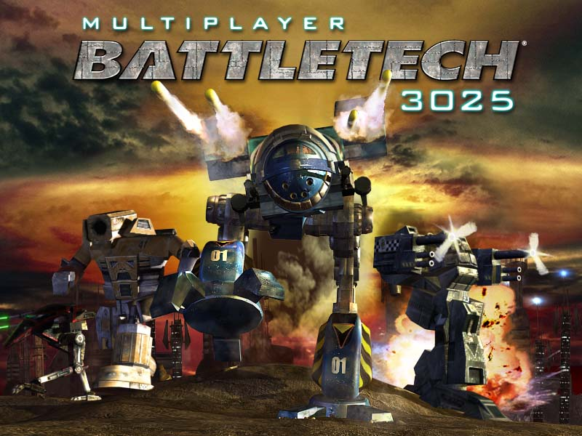

Player's Guide



Contents

Contents 2
Introduction 5
Installation 6
System Requirements 7
Getting Ready 8
Pilot Creation 8
Pilot Training 8
Solaris 9
Training on Solaris 9
Returning to Solaris 11
House Selection 12
Inner Sphere Map 13
Staging Area 16
Enter Mission 17
Mission Room 18
Ready 20
Battle Results 21
Chat 23
Score, Levels, Rank & Salary 25
Scoring 25
Levels 26
Ranks 27
Salary 28
Combat 29
Basic Operations 29
Radio 29
Radar 30
Bogey Indicators (Line-of-Sight Arrows) 30
Movement 31
Torso Twisting 31
Jumping 32
Mouse Controls 32
Keyboard Controls 33
Joystick Controls 34
Combat Controls 34
Targeting 34
Zoom 35
Firing Weapons 36
Weapon Groups 37
Ramming 39
Heat 39
Climate 40
Damage 40
Falling Down 41
Destruction 41
'Mechs 43
Individual 'Mechs 45
Weapons 52
Menu Bar 54
Game 54
Credits 54
Exit 54
Community 55
Contact List 55
Ignore List 55
Options 56
Video Options 56
Audio Options 57
Control Options 57
Word Filter 58
Help 59
Pilot Training 59
Show This Screen's Tutorial 59
Page a Sysop 60
File a Report 60
Find 60
Find Player 60
Find Planet 61
My 'Mechs 62
My Stats 64
Credits 66
Copyright Notice 70

Introduction

Welcome to Multiplayer BattleTech: 3025. The year is 3025, and five great military Houses wage epic battles within the Inner Sphere, an area of space that extends approximately 500 light years in every direction. Using massive war machines, these Houses fight an endless war to control and claim each of the 120 territories within the Inner Sphere.

You are a MechWarrior, an elite soldier pledged to the glory of your House and eternal battle. Fighting like a knight in the Age of Chivalry, you possess the armor, weapons and steel to accomplish your calling -- the BattleMech. Weighing from 25 to 100 tons, you will control these agile, armored behemoths in planetary battles across the Inner Sphere and determine the balance of power, once and for all...

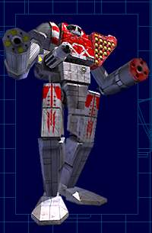

Installation

Before you can play Multiplayer BattleTech: 3025, you must install it on your computer.

1. Go to http://www.ea.com. Select Multiplayer BattleTech: 3025 from the gamefinder menu on the left side of the page and click Go!

2. Click Login. (If you do not already have an EA.com login, you first need to click Subscribe and follow the instructions to create your member name and sign up for the EA PLATNIUM Service, which is required to play this game.)

3. After you log into the game with your member name and password, click Play.

4. If you don't already have the EA.com Game Installer -- required to install any games from EA.com -- you'll be asked if you want it installed on your computer. Click Yes. You'll be prompted for the directory where it should be installed. Use the default directory, or choose your own, and then click OK. The EA.com Game Installer will be set up on your system, and the installation of Multiplayer BattleTech: 3025 will resume automatically.

5. You will be prompted for the directory where Multiplayer BattleTech: 3025 should be installed on your computer. Use the default directory, or choose your own, and click OK.

6. The game will download and install. When the installation is complete, the game launches automatically.

System Requirements

Minimum Platform:
Pentium II 266 MHz (or equivalent)
64MB of RAM
30MB free hard drive space
3D hardware accelerator with 16MB of RAM and nVidia TNT, 3dfx Voodoo 3, or equivalent functionality
28.8 Modem and Internet access
SoundBlaster or equivalent sound card
Keyboard and mouse
DirectX 8.0 or higher

Recommended Platform:
Pentium III 500 MHz (or equivalent)
128MB of RAM
30MB free hard drive space
3D hardware accelerator with 32MB of RAM and nVidia GeForce 256 or equivalent functionality on AGP bus
56k Modem and Internet access
SoundBlaster or equivalent sound card
Joystick
DirectX 8.0 or higher

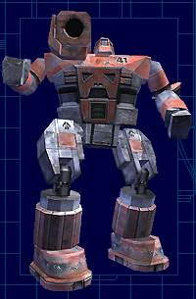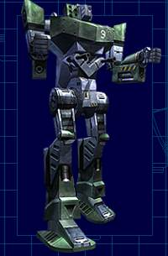

Getting Ready

This section describes the lobbies and interfaces you'll encounter when first entering Multiplayer BattleTech: 3025, including pilot creation and training, the gladiatorial planet Solaris, House Selection; then the Inner Sphere Map, where you'll review your House's territory and decide which planet to attack or defend; the Staging Areas, where you'll meet and chat with other pilots; and the Mission Rooms, where you'll form teams and launch into battle.

Pilot Creation
When you enter Multiplayer BattleTech: 3025 for the first time, you'll be asked to choose a call sign. This is the name you'll be known by in the game. Be sure to choose a name you like, because you can't change it later without creating a new pilot from scratch. Also, you can't choose a call sign that is already in use, or one that contains offensive language.

Once you enter your call sign and click Ok, you're ready to begin Pilot Training.

Pilot Training
Pilot Training is a special single-player mode designed to teach you the basics of operating a BattleMech. You will automatically be given the option to begin training when you create a pilot. You can also access Pilot Training anytime by selecting it from the Help menu in the top menu bar or from the My Stats information screen, also on the top menu bar.

Basic Training | Advanced Piloting | Advanced Combat | Practice Battle
Learn the basics of 'Mech movement, communication, and standard weapons usage. | Learn the advanced skills of torso twisting and the zoom camera operation. | Learn the specifics of advanced weapon grouping and your Heads-Up Display (HUD) elements. | Hone your skills with seven other 'Mechs in a practice battle.

You can either begin with the first lesson and progress through the entire training program, or pick only the lessons you wish. Click the right and left arrows in the Lesson Selector box to cycle through the lessons; the description of each one appears in the box below. Click the flashing Begin Lesson button to give the displayed lesson a try, or, when you are ready to leave training, click Exit Training.

Once you click Begin Lesson, you will appear in a trainee's Commando-4D 'Mech. Follow your instructor's orders to progress through the lesson, or you can quit anytime by pressing the <esc> key.

Veteran's Note:
No, you cannot blow up your instructor.

Solaris

Solaris is a gladiatorial planet set aside by mutual consent of the Houses for neutral combat and training. Solaris is actually within the Inner Sphere, but is called out separately in the Inner Sphere Map for clarity's sake.

Before you can join a House and begin fighting in the Inner Sphere, you must first prove your piloting skills on Solaris. After you fight enough battles to be promoted from Cadet (this requires 1200 rank points) you will receive a Solaris Graduation Medal and be recruited to choose a House that you will fight for.

You can also return to Solaris any time after graduation for practice battles and special events.

Training on Solaris
To enter Solaris, click the Go To Planet button on the Inner Sphere Map after you complete Pilot Training. You will appear in one of the City Lobbies on Solaris. These lobbies have similar functionality as the Staging Areas that you will use throughout your career as a MechWarrior. However, on Solaris the opposing forces are called Lance Alpha and Lance Beta (a Lance is a squad of up to four BattleMechs) and it is possible to train solo against computer AI as well as with live players.

Pick a mission from the Mission List in the center of the screen. You can either choose one of the missions that already contains other players, or choose an empty mission to practice alone. (Someone still might come and join you in the Mission Room before combat starts, though.) Click Enter Mission.

You'll appear in a Solaris Mission Room, in an available Lance Alpha or Lance Beta battle seat. You can take any seat in the room by double-clicking on it; on Solaris, you are not limited to one side or the other. However, you can only play against other cadets; experienced pilots returning to Solaris cannot join your battles.

From your seat, you only have to click the flashing Ready button to indicate that you are ready for combat. The 60-second countdown timer will begin, after which you'll be launched into a practice battle. If you are the only Ready player, you will be fighting computer-controlled 'Mechs. If all Ready players are on the same team when the battle is launched, the game will automatically rebalance the mission.

When the battle is finished, you will see a Battle Results screen outlining how many Rank points you earned in combat. When you reach 1200 Rank points, you will receive your Solaris Graduation Medal and be given the opportunity to leave the planet and choose a House to fight for.

You will find that the My 'Mechs and My Stats buttons on the top menu bar are grayed out during this phase of your training. They will be activated as soon as you graduate from Solaris.

For complete details about using any of these screens or about participating in combat, refer to these sections of the manual:

- Staging Area
- Mission Room
- Combat
- Battle Results
- Scoring

Returning to Solaris
Experienced pilots may return to Solaris anytime after graduation by clicking on it on the Inner Sphere Map. A dialog will appear listing the sixteen major cities, along with the number of 'Mechs currently occupying each city. Any city that has reached its maximum capacity of 'Mechs is shown as FULL. Select one and click Go To City, or click Cancel to return to the Inner Sphere Map.

Solaris is a good place for informal combats between friends, challenges between members of the same House, or to experiment with new battle strategies or techniques. This is also an ideal environment to familiarize yourself with new 'Mechs after purchase; there is no weight class limit on Solaris.

Special events, such as prize tournaments or contests, will also be held on Solaris from time to time. Keep your eye on the Multiplayer BattleTech: 3025 home page for information about upcoming events.

Veteran's Note:
Solaris cannot be controlled by any of the five Houses, and therefore no Rank points or C-bills will be awarded for battles you fight here after finishing Cadet training and joining a House.

House Selection

Ready to join the battles of the Inner Sphere? The only thing left to do after earning your Solaris Graduation Medal is to decide which of the five Houses you wish to fight for. This will determine who your allies and enemies are, as well as your initial starting salary and the Rank titles you will earn as you increase in level.

Veteran's Note:
Houses in immediate need of manpower offer financial incentives for signing up on their side. You will be notified before choosing a House if such an offer is currently available.

Davion | Kurita | Liao | Marik | Steiner
The Davions, ruling the Federated Suns, ushered in a new era of military strength as well as scientific advancement. | House Kurita embraces bushido, the Japanese 'way of the warrior'. No House is as universally feared and respected as House Kurita. | Emperor Maximillian Liao is devoted to reclaiming his faded empire, and walks the fine line between genius and madness. | Janos Marik is the appointed leader of the Free Worlds League, the oldest of all the Inner Sphere Houses. | House Steiner rules the Lyran Commonwealth, a mercantile and military powerhouse second to none.

Use the arrows at either side of the Choose House field to view the five available Houses and their descriptions. When you find one you like, click on it and then click Next.

Inner Sphere Map

After you graduate from Solaris and choose a House, you'll find yourself viewing the Inner Sphere Map. From here, you select a planet for which to battle. Your goal is to expand your House's territory -- to win as many new planets for your House as possible while defending the planets you have already won. The more planets your House controls, the larger your personal salary will become.

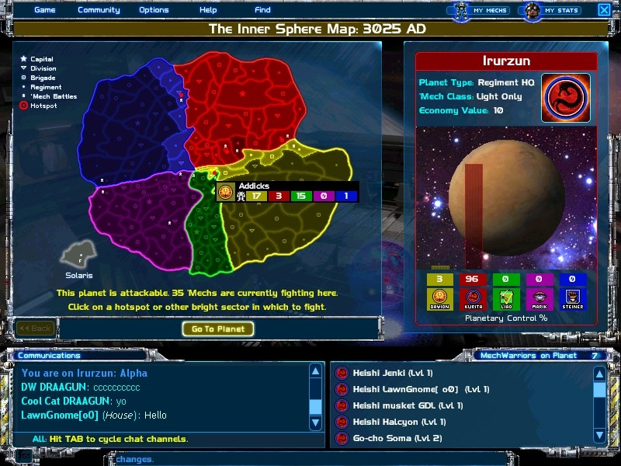

The Inner Sphere map displays the overall territory owned by each House. The map is constantly in flux, as planets are won or lost in the ongoing battles between the Houses. The map is updated in real time whenever a planet changes hands from one House to another.

You can battle as a defender on any planet controlled by your House, or as an attacker on any planet adjacent to your House's territory. These eligible planets will be highlighted in a brighter color on your Inner Sphere Map. Move your mouse over any of these for a popup of basic information about the number of 'Mechs on the planet. When you select the planet by clicking on it, the information box on the right side of the screen gives you more in-depth information:

- The planet's name. The color of this bar, and the House icon beside it, indicate which House currently controls the planet.
- Planet Type: this determines the 'Mech Class allowed on the planet. Higher class 'Mechs are allowed on planets with higher strategic and economic value. The types, starting with the most strategic importance, are: Capital, Division HQ, Brigade HQ, and Regiment HQ.
- 'Mech Class: the maximum weight class of 'Mechs allowed on the planet. Less-strategically important planet types only allow lighter 'Mechs; for example, a Brigade HQ will only allow medium class 'Mechs or lower.
- Economy Value: affects your total House Econ Value (and therefore your salary) if the planet is won or lost by your House. This number is determined by the Planet Type, above.
- The image of the planet. The planet's appearance indicates the predominant terrain and climate conditions. Climates include badlands, arctic, arid and temperate. You may also see explosions on the planet's surface; the more explosions, the more 'Mechs are currently on the planet.

Below the planet's description you'll see a row of five colored boxes, each representing one of the five Houses, with a number and a color-coded bar indicating that House's percentage control of the planet. Arrows appear when planetary balance shifts, showing which House most recently won or lost a percentage of control. This percentage value is critical to check; the closer your House is to either gaining or losing control of the planet, the more important it is for you to jump into battle to tip the number in your favor!

To go to a planet, either double-click it on the Inner Sphere Map, or select it first and then click the Go To Planet button. Each planet has several important strategic sectors to fight for. You'll be presented with a list of these sectors, including the number of 'Mechs currently occupying each one. Sectors that have reached the maximum number of 'Mechs allowed by port authority are shown as FULL. Click on any non-full sector in the list, and then click Go To Sector to go to that sector's Staging Area.

Veteran's Note:
Planet territories with flashing red epicenters (hotspots) are current hotbeds of activity. Four hotspots appear for each House: two that are determined by the highest number of 'Mechs on the planet, and two determined by the lowest margin of House control. If you're looking for action, check out those planets first.

The bottom portion of the Inner Sphere Map is dedicated to chatting; read the section on Chat for information on its use.

Staging Area

Every planet in Multiplayer BattleTech: 3025 has several Staging Areas in strategic orbits above the planet's surface. From the Staging Area you can chat with other pilots, then review the sector's active missions and then Enter a Mission, from which you'll be launched into combat.

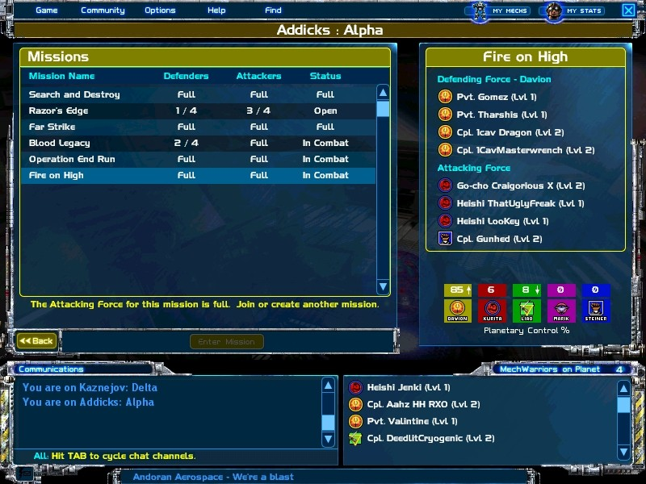

The large Mission window on the left lists all the active Mission Rooms for the sector. You'll see the Mission names, the number of attackers and defenders in each Room (displayed as the number of filled seats / total seats available for each side,) and the room's status: Open, Full, or In Combat.

The display on the right side of the screen shows more information about the selected Mission. You'll see the names, House icons, ranks and levels of the pilots in the battle seats for both the attacking and defending teams. These are the teams that will battle in the next combat in that Mission Room! A seat with no pilot in it is still empty; if the empty seat is on your side (defending or attacking, depending on whether your House currently controls the planet) you can click Enter Mission to enter the Mission Room and take that seat.

Below the mission details on the right are five colored boxes, one for each House, with numbers indicating each House's percentage control of the planet. Small white arrows appear by the percentage numbers when planetary balance shifts, showing which House most recently won or lost a percentage of control.

The bottom portion of the Staging Area is dedicated to chatting; read the section on Chat for information on its use.

Click <<Back anytime to return to the previous screen.

Enter Mission

To enter a Mission, highlight it and click Enter Mission, or double-click on the Mission name. You'll be placed in one of the empty battle seats on your side (Attacker or Defender). If you enter an 'In Combat' Mission, you'll be placed in a seat but not in the current battle -- click Ready to participate in the next battle fought in that Mission Room.
Veteran's Note:
If the maximum number of Missions is already active on the planet, you won't be able to create a new Mission even if there is no qualified seat available. You'll have to choose a different planet, or wait for an opening on that one.

Visit the section on Mission Rooms for complete information about how the Mission Room works.

Mission Room

The Mission Room is used to gather teams of players together for battle. When you enter a Mission Room you are immediately strapped into an empty battle seat for either the Defending or the Attacking force, depending on which House and Territory you are fighting for. (If your currently select 'Mech is too heavy for the weight class limitation of the planet, you'll be sent to the My 'Mechs screen to select a lighter 'Mech before you can take a battle seat.)

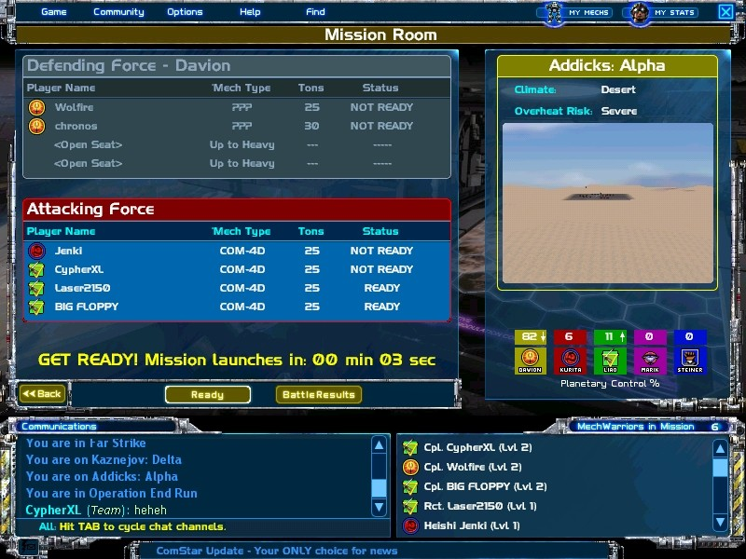

From your battle seat, all you have to do is click the Ready button to indicate you are ready for combat. Missions are automatically launched 60 seconds after the first player clicks Ready; if you're Ready when the timer runs out, you'll be launched into combat.

The information box on the right side of the Mission Room displays the planet and sector you are in, the climate of the planet overall, and the overheat risk for the upcoming mission. The large graphic is a depiction of the combat area, showing the conditions you'll encounter in the upcoming drop.
Veteran's Note:

Experienced pilots use climate information strategically to select the best 'Mech for the battle. For example, if you see that you'll be fighting in an arid climate with a high overheat risk, you might want to select a 'Mech with as many heat sinks as possible.

Below the graphic of the combat area you'll see a row of five colored boxes, each representing one of the Houses, with a number indicating that House's percentage control of the planet. Arrows appear when planetary balance shifts, showing which House most recently won or lost a percentage of control.

On the left side of the screen, boxes for the Defending and Attacking forces display open and occupied seats. When a seat is occupied, you'll see the name of the pilot, an icon showing his House allegiance, the type of 'Mech he is using (unless he is not on your team, in which case you can see his 'Mech's tonnage but not the exact type), his 'Mech's tonnage, and his status: Ready, Not Ready, In Combat, Viewing Score or Selecting 'Mech.

The bottom portion of the Mission Room is dedicated to chatting; read the section on Chat for information on its use.

Veteran's Note:
It is possible for the sides to suddenly "switch places" in the mission listings. For example, if your House has been defending and you lose control of the planet, the new Controlling House will be moved to the Defending side, and you will now be listed on the Attacking side.

Ready
Click the Ready button to indicate that you're ready for battle. (The 60-second autolaunch timer begins as soon as the first person clicks Ready.) If you change your mind, this button changes to a Not Ready button once clicked, so you can click it again to back out.

The battle launches when the 60-second autolaunch timer expires or when all eight seats are filled and Ready, whichever is sooner. When combat begins, all Ready pilots are sent to the battlefield, while Not Ready pilots remain in their seats in the Mission Room.

There will always be a final 10-second countdown before launching into battle.

Veteran's Note:
During the final 10-second countdown, it is still possible for players to enter or leave the upcoming mission by changing their Ready states.

Note that Multiplayer BattleTech: 3025 includes an autowin scenario. If only one side is seated and Ready when the auto-launch timer expires, that side’s House automatically wins the battle. The percentage control of the planet, although the change will be quite small, is updated accordingly.

Battle Results
This screen displays the results of the latest battle fought from the Mission Room. The information for the Attackers and Defenders appears separately, with a victory banner over the box for the winning team. Each information box displays the names of each team member, each person's solo points, team points, penalty, and point total. See the section on Scoring for an explanation of these numbers.

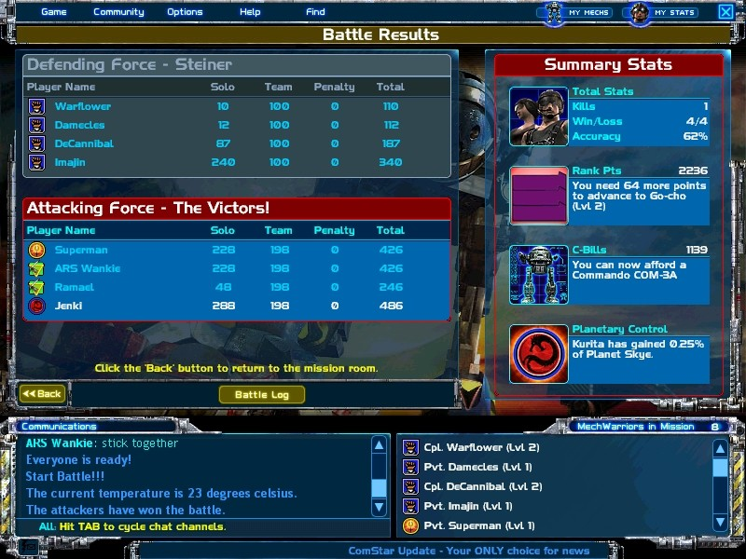

On the right column you see basic information about your pilot. On the top is the Total Stats box, showing your kills, total wins/losses, and your accuracy percentage. Next are your total Rank Points, including information about how many more points you require to advance to your next level. Your total C-Bills follow, with the name of the most expensive 'Mech you can currently afford.

The Planetary Control box at the bottom of the right column displays the percentage of planetary control the victorious House has gained with this battle. Depending on the number of Missions currently being fought on the planet, the overall percentage of control -- viewed in either the Inner Sphere Map or a Staging Area -- will be affected more or less by each completed battle. (Your recent loss, for example, might be negated by a victory for your House in another Mission Room.)

The Battle Log button displays the complete battle log, which is a blow-by-blow account of the major events in the battle. Click <<Back to return to the Staging Area.

Chat

The Chat interface appears at the bottom of the Inner Sphere Map, the Staging Areas, the 'Mech Bay, and the Mission Rooms. You can also chat in combat, using the same controls as in these areas. Press Tab on your keyboard to activate chat.

Three color-coded chat channels are available, depending on which other players you wish to be able to view your messages. The following channels are available:

- All: (CYAN) Outside combat, use this channel to chat with everyone in the current room. In combat, use this channel to chat with members of both teams. This can be seen by noncombatants waiting in the Mission Room.

- House: (WHITE) Outside combat, use this channel to chat with all members of your House who are in your current room. In combat, use this channel the same way. Remember, though, that not everyone on your team is necessarily allied with your House!

- Team: (LT. GREEN) This is the default channel in combat and in Mission Rooms, and is only available in those areas. Use this channel to send messages to all members of your team, regardless of their House affiliations. Noncombatants won't see messages on this channel.

Cycle channels with the Tab key. Once you've selected your channel, enter your message in the narrow chat bar and hit the Enter key. Your message will appear in the large Communications box above. (Note: if you are not in combat and you want to send a private message to an individual, you may right-click on the recipient's name and select Flash Message rather than using chat. If you receive a flash message, a flash message button will light up in the lower left corner of the chat window; click the button and then the sender's name to receive your message.)

Veteran's Note:

In combat emergencies, you'll have more on your mind than just chatting. Type Shift+Tab anytime to quickly get out of chat mode and return all keyboard inputs to 'Mech controls.

At the bottom of the Chat interface is the ComStar Update Ticker. Keep your eyes on this -- every few minutes, the latest news of the war scrolls across this ticker. This news ranges from the names of planets that are close to being captured to planets with the most player activity.

Score, Levels, Rank & Salary

As you fight battles against other 'Mechs, you gain C-bills and Rank points, and eventually increase in level. As you attain certain levels, you become qualified to use heavier-class 'Mechs. (Click My 'Mechs to purchase new 'Mechs.)

Scoring
At the end of every Mission, you can view your Solo Score, your team's overall Team Score, your penalties and your Total Score in the Battle Results screen.

Your Solo Score represents how much damage you personally inflicted on your opponents during combat. The major events that increase your Solo Score are:

- Breaching an opponent's external armor -- a body part turns red on your target display.
- Blowing off an opponent's limb -- an arm or leg turns black on your target display.
- Destroying another 'Mech.

It's important to note that the exact number of points you gain by destroying a 'Mech is affected by the battle-readiness of your target: the more damage your target has already taken from other players, the fewer points you'll receive. Also, the value of the 'Mech you damage or destroy affects your points as well -- more valuable 'Mechs award more points.

Veteran's Note:

Resist any temptation to shoot your teammates. Friendly fire results in a heavy Penalty Score, as well as lowering your team's confidence in you.

Every player who enters battle, regardless of the outcome, receives Team points. If a team loses, every member is given a flat 100-point 'team effort' bonus in addition to whatever they earned in Solo points. Team Score is calculated by taking every team member's Solo Score and distributing the total between all members.

Your Total score is the total number of Solo points plus Team points minus any Penalty points.

Levels
In Multiplayer BattleTech: 3025, you can achieve up to 99 levels by gaining rank points in combat. When you reach Level 8, you can begin piloting Medium class 'Mechs; Level 21 for Heavy class, and Level 30 for Assault class.

The following tables show how many points are required for each level promotion, with highlights indicating the levels required to qualify for each heavier 'Mech class.

Level | Points
1 | 1200
2 | 2000
3 | 5000
4 | 10,000
5 | 18,600
6 | 30,500
7 | 45,600
8 | 65,000
9 | 90,400
10 | 121,600
11 | 158,600
12 | 201,400
13 | 251,100
14 | 307,700
15 | 385,900
16 | 473,800
17 | 572,900
18 | 683,200
19 | 806,000
20 | 941,400
21 | 1,089,400
22 | 1,271,100
23 | 1,470,000
24 | 1,686,100
25 | 1,919,400
26 | 2,171,500
27 | 2,444,000
28 | 2,736,800
29 | 3,050,000
30 | 3,385,100
31 | 3,784,400
32 | 4,224,300
33 | 4,708,200

Level | Points
34 | 5,239,500
35 | 5,824,900
36 | 6,467,900
37 | 7,175,200
38 | 7,953,500
39 | 8,809,700
40 | 9,750,500
41 | 10,888,800
42 | 12,142,400
43 | 13,522,500
44 | 15,040,300
45 | 16,710,600
46 | 18,548,300
47 | 20,568,300
48 | 22,789,100
49 | 25,233,100
50 | 27,922,700
51 | 30,880,100
52 | 34,135,100
53 | 37,717,500
54 | 41,657,000
55 | 45,990,800
56 | 50,759,800
57 | 56,005,000
58 | 61,774,700
59 | 68,121,000
60 | 75,103,400
61 | 82,785,200
62 | 91,237,000
63 | 100,533,300
64 | 110,759,600
65 | 122,008,900
66 | 134,381,600

Level | Points
67 | 147,993,100
68 | 162,966,100
69 | 179,438,300
70 | 197,558,400
71 | 217,490,200
72 | 239,415,900
73 | 263,532,700
74 | 290,060,000
75 | 319,239,700
76 | 351,335,900
77 | 386,642,400
78 | 425,479,200
79 | 468,199,700
80 | 515,190,700
81 | 566,880,100
82 | 623,740,300
83 | 686,288,400
84 | 755,089,800
85 | 830,773,200
86 | 914,026,800
87 | 1,005,605,800
88 | 1,106,343,400
89 | 1,217,154,800
90 | 1,339,048,000
91 | 1,473,131,700
92 | 1,620,622,300
93 | 1,782,862,700
94 | 1,961,326,000
95 | 2,157,634,100
96 | 2,373,572,700
97 | 2,611,105,900
98 | 2,872,391,300
99 | 3,159,805,900

Ranks
Each of the five Houses has nine ranks associated with levels 1-30. Each rank for each House has a unique name and icon.

Level | Davion | Kurita | Liao | Marik | Steiner
1 | Private | Heishi | Recruit | Private | Private
2-4 | Corporal | Go-cho | Lance Corporal | Corporal | Corporal
5-7 | Sergeant | Gunsho | Lance Sergeant | Sergeant | Sergeant
8-10 | Sergeant-Major | Sho-ko | Asst. Force Leader | Sergeant Major | Sergeant Major
11-15 | Leftenant | Chu-i | Force Leader | Lieutenant | Leutnant
16-20 | Captain | Tai-i | Captain | Captain | Hauptmann
21-25 | Major | Sho-sa | Major | Force Commander | Kommandant
26-29 | Leftenant Colonel | Chu-sa | Senior Major | Lieutenant Colonel | Leutnant Colonel
30-93 | Colonel | Tai-sa | Regimental Colonel | Colonel | Colonel
94 | Leftenant General | Sho-sho | Assistant Force Commander | Lieutenant General | Leutnant-Colonel
95 | Marshal | Tai-sho | Force Commander | Major General | Hauptmann-General
96 | General | Tai-shu | Director | General | Kommandant-General
97 | Field Marshal | Warlord | Senior Colonel | Marshal | General
98 | Marshal of the Armies | Gunji-no-kanrei | Senior Military Coordinator | Senior Marshal | General of the Armies
99 | Prince | Coordinator | Chancellor | Captain-General | Archon

Salary
Every twenty-four hours, each pilot automatically receives a salary based on the total Econ of all the planets owned by his house, plus a small multiplier based on level. This happens whether or not you log into the game. Salary fluctuates constantly based on the victories and defeats suffered by your House; check the My Stats screen for your most current salary level.

(If your salary seems a little low, there are two good ways to raise it -- increasing your level, and winning some new planets for your House!)

Combat

When you are launched into battle, the game's appearance changes. You appear on the battlefield in your 'Mech's cockpit. The terrain stretches before you, and around the edges of your screen are various status indicators that comprise the HUD (Heads Up Display). For the next fifteen minutes (or less, if the battle resolves sooner) your mission is to pilot your 'Mech, blow away your opponents, and keep from getting blown away yourself.

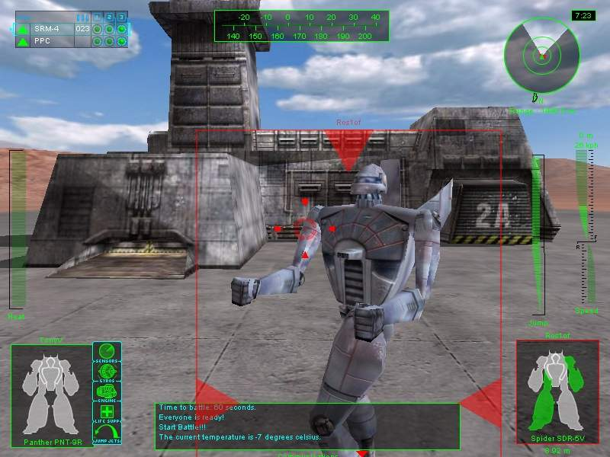

Basic Operations
Before you rush into battle, make sure you're familiar with the basic operations of your 'Mech: the radio, radar, and bogey indicators, the movement and speed controls, torso twisting and jumping, along with the joystick, mouse or keyboard controls you'll need to survive.

Radio
Communicating with other pilots during battle is crucial. You will want to coordinate strategies with members of your team, call for help, and also to taunt and demoralize your opponents.

To use your radio to send a message press TAB. Pressing TAB repeatedly will cycle through the three channels: messages to everyone on the battlefield, messages to only your own team, and messages to only members of your own House. Once you've chosen a channel, type your message and hit ENTER. Use Shift-TAB to quickly exit chat mode without sending the contents of your chat buffer.

Radar
The radar display in the upper right corner of the HUD (Heads Up Display) shows your position relative to all other 'Mechs in the battle. 'Mechs on your team will be green on the display, enemy 'Mechs will be in red, and destroyed 'Mechs in black.

Your 'Mech is always in the center of the radar display, moving toward objects at the top of the radar. The clear wedge on the radar indicates your current line of sight. Thus, if you have twisted your torso to look in one direction while walking in another, the line of sight wedge will be angled in the direction of your torso, while the radar remains oriented to show you moving toward the top of the radar display.

The - key zooms the radar in for a closer view; the = key zooms it out. (You can configure your joystick to perform the radar zoom functions by going to the Control Options screen.)

Bogey Indicators (Line-of-Sight Arrows)
At the beginning of combat, your opponent's current position is reported via the red triangular bogey indicators that appear at the top edge of the HUD. These will soon fade, and for the rest of the combat a red bogey indicator will only reappear when at least one of your team's 'Mechs spots an opponent 'Mech.

The green bogey indicators, which point toward 'Mechs on your own team, are always visible in your HUD. The black bogey indicators point toward destroyed 'Mechs, in case you want to check out the carnage.

Movement
You can move and turn your 'Mech using the keyboard, mouse or joystick; go to the Control Options screen to customize these controls. The default movement controls on the keyboard are:

- W Move forward
- X Stop
- S Move backward
- A Turn left
- D Turn right

The speedometer on the right edge of your HUD shows your current speed, either forward or backward. Different 'Mechs have different top speeds. Heavily armored 'Mechs, or 'Mechs loaded down with many weapons, move more slowly than their leaner counterparts. Adjust your strategies accordingly.

Veteran's Note:
Remember, the faster you're moving, the longer it takes to turn!

Torso Twisting
You can rotate your 'Mech's top torso independently of your legs, up to 90 degrees either right or left, giving you a full 180 degree arc. You can also tilt your torso up and down, enabling you to fire at targets higher or lower than you on the terrain.

The Heading Bar at the top center of your screen gives information about the direction your torso is twisted, as well as your overall heading. The top half of the bar shows the number of degrees you are twisted, and the bottom half of the bar shows your overall compass heading in numeric form (0 indicates true North.)

Another way to quickly verify your current torso alignment is to check your radar. The clear wedge on the radar indicates your current line of sight, while your 'Mech is always moving toward the top of the radar display. Thus, if you have twisted your torso, the line-of-sight wedge will be angled away from the top of the display, in the current direction of your torso.

You can twist and tilt your torso using the keyboard, joystick or mouse; visit Control Options to configure the controls. Re-center your torso anytime by pressing C, or you can stabilize your 'Mech (come to a complete stop and re-center torso) by pressing ~.

Jumping
Some 'Mechs are equipped with jump jets, which enable you to briefly take to the air. The Jump Fuel Meter, on the right side of your HUD next to your speedometer, indicates the duration of your jump; when the bar turns red, you're on your way back to the ground and will have to wait for your jump jets to recharge before you can jump again. This meter doesn't appear if your 'Mech is not equipped with jump jets.

If you are stationary when you jump, your 'Mech will jump higher but have no forward movement; a 'Mech at a full run will execute a long, but shallow, jump.

To jump, press the space bar. Once you are airborne, use the standard movement controls to maneuver. (Go to the Control Options screen if you want to configure your joystick to control your jumps instead.) Naturally, these commands won't work if your 'Mech is not equipped with jump jets, or if your jump jets have been destroyed.

Mouse Controls
The default mouse controls are listed below. If you want to change the mouse controls, open the Options menu from the bar across the top of your screen, then select Control Options.

Default Mouse Controls
LMB | Fire Selected Weapon
ALT LMB | Grab and drag HUD component
RMB | Fire Selected TIC
Move left or right | Turn 'Mech in desired direction
Move up or down | Tilt 'Mech up or down

Keyboard Controls
The default keyboard controls are listed below. If you want to change the keyboard controls, open the Options menu from the bar across the top of your screen, then select Control Options.

Default Keyboard Controls
Mech Movement |  |  | Weapon Controls
Forward Throttle | W |  | Fire Selected Weapon | Left Alt / LMB
Reverse Throttle | S |  | Select Next Weapon | 5 / Mouse Wheel
Stop (0 Throttle) | X |  | Select Previous Weapon | 4 / Mouse Wheel
Turn 'Mech Left | A / Mouse Left
Turn 'Mech Right | D / Mouse Right |  | TIC Weapon Controls
Engage Jump Jets | Space |  | Fire Selected TIC Weapons | Left Ctrl / RMB
Stand Up | G |  | Fire TIC 1 Weapons | Delete
Stabilize | ~ (tilde) |  | Fire TIC 2 Weapons | End
Eject (Quit Mission) | Esc |  | Fire TIC 3 Weapons | PgDn
 |  |  | Select Next TIC Weapons | Insert
Mech Torso Movement |  |  | Select Previous TIC Weapons | PgUp
Tilt Torso Up | Up / Mouse Up |  | Select TIC 1 | 1
Tilt Torso Down | Down / Mouse Dn |  | Select TIC 2 | 2
Twist Torso Left | Q |  | Select TIC 3 | 3
Twist Torso Right | E |  | Map Weapon to TIC 1 | Shift 1
Center Torso | C |  | Map Weapon to TIC 2 | Shift 2
 |  |  | Map Weapon to TIC 3 | Shift 3
Targeting Controls |  |  | Toggle Mouse Cursor on/off | Backspace
Select Enemy Target | T
Target Next Enemy | R |  | View Controls
Target Next Friendly | F |  | Look Forward | Numpad 8
 |  |  | Look Back | Numpad 2
Zoom In | = |  | Look Left | Numpad 4
Zoom Out | - |  | Look Right | Numpad 6
Set Zoom to 0% | . (comma) |  | Look Up | Numpad /
Set Zoom to 50% | / |  | Look Forward Left | Numpad 7
Set Zoom to 100% | . (period) |  | Look Forward Right | Numpad 9
 |  |  | Look Back Left | Numpad 1
Chat Controls |  |  | Look Back Right | Numpad 3
Activate Chat / change chat channels | Tab |  | External View Toggle | F10
Quick-exit chat | Shift-Tab
 |  |  | Misc. Controls
HUD Controls |  |  | Combat Help Screen | F1
Cycle Player Damage Display | Numpad 0 |  | Combat Screen Capture | F11
Cycle Target Damage Display | Numpad . (period) |  | Combat Frame Rate Display | O

Joystick Controls
Multiplayer Battletech: 3025 is fully playable by joystick. Because joystick configurations are so varied, you may need to custom-configure some of the controls by opening the Options menu in the menu bar and then selecting Control Options.

The default joystick controls are listed below:

Default Joystick Controls
Joystick 1 | Fire current weapon
Joystick 2 | Select crosshair target
Joystick 3 | Select next TIC as firing TIC
Joystick 4 | Fire currently selected TIC

Combat Controls
The time has come. You've created your pilot, picked your 'Mech, found at least one opponent, and now you're ready to inflict some damage. This section covers targeting your enemy, how to zoom your view, firing your weapons and using weapon groups (TICs), ramming another 'Mech, the effects of climate, heat and overheating, taking damage, what to do if you fall down, and what happens if your 'Mech is destroyed.

Targeting
The first step toward destroying an opponent 'Mech is to target it with your scanner. When an opponent is within your line of sight, indicated by the appearance of the red line-of-sight arrows in your HUD, press T to target.

Veteran's Note:
The T key will allow you to view a battle after your 'Mech has been destroyed, as long as you have teammates still fighting.

Note that it is not absolutely required to target another 'Mech in order to shoot at it, but targeting can be of great help, especially for less-experienced pilots.

When you target another 'Mech, an indicator box appears around that 'Mech on your screen. When your target is in range of your currently selected weapon, arrows will appear around the perimeter of the indicator box.

Your reticle will also change depending on whether you’ve targeted a ‘Mech and are in range. The reticle will turn red if it is over an enemy ‘Mech but out of range. If your reticle is over the ‘Mech and you are in range of your currently selected weapon, it will turn red and animate, letting you know you have a clear shot at the enemy. Finally, if you’ve targeted a ‘Mech but your reticle is not over it, a small blue arrow will point in the direction of the ‘Mech, telling you where to move.

The Target Display box appears in the lower right corner of the screen when a 'Mech is targeted. The Target Display box displays a diagram of your target. Press Delete on the numpad to toggle between front and back views. This diagram shows the damage levels of your target's various systems:

Damage Display
White | Undamaged
Green | Lightly damaged
Yellow | Heavy damaged
Red | Armor has been breached
Black | Component is destroyed (black chest or head indicates total destruction.)

Zoom
You can use the Zoom function to zoom your view, helping you see what's going on in the distance, or to target a long-range opponent. The = and - keys on your keyboard increase and decrease zoom incrementally. The , (comma) key increases zoom magnification to maximum, / is one-half zoom, and . (period) returns your view to normal.

Firing Weapons
Your 'Mech's weapon list appears in a box at the upper left corner of your HUD. This box displays important status information about each weapon.

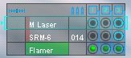

The first icon in each row is the range indicator; a number shows the distance until the targeted 'Mech gets within range of the weapon; a green arrow confirms that the target is within the weapon's range. The weapon name follows, which also doubles as the weapon recharge rate graph. After firing the weapon, it will not be available again until the weapon bar fills all the way up and turns green. Next is the ammo indicator; if the weapon requires ammo, total ammo remaining is displayed here. Last is the firing status display; a hollow circle means that the weapon is recharging and cannot be fired, and a solid green circle indicates that the weapon is ready to fire. The TIC (Target Interlock Control) is also part of this firing status display (see the section on Weapon Groups for more information about the TICs.)

At the start of the battle, the first weapon in the box is automatically highlighted. This weapon also happens to have the longest range. Every time you fire a weapon, the next weapon on the list in the current TIC will be highlighted in turn, enabling you to rapid-fire your weapons by hitting Left ALT (the ALT key on the left side of your keyboard) repeatedly. The left mouse button and the joystick trigger 1 also fire your weapon. To select a different weapon, use the 4 or 5 keys to cycle up or down the list.

Note that you are constrained in weapon selection by your currently selected TIC. If only some of the weapons are selected by the current TIC, these are the only ones that can be chosen as the next weapon to fire.

Once you have an opponent centered in the reticle, you are ready to fire! Press Left ALT to fire your selected weapon.

Veteran's Note:
If your target is properly lined up when you fire a weapon, you automatically achieve a target lock. This means that your missiles and ballistic weapons will hit even if your target moves while you're firing... although missiles are less precise about exactly where on your opponent they'll strike.

Weapon Groups
One way to victory is to use weapon groups, which allow you to fire multiple weapons at the same target simultaneously. The advantage to this technique is that you can inflict more damage per shot; the disadvantage is that you raise your Heat level faster, and your weapon group may miss its target, stranding you without available weapons until they recharge.

You can set up three weapon groups, or TICs, using combinations of whichever weapons are available on the 'Mech you are piloting. The TICs are displayed in the weapon display in the upper left corner of your HUD. The small grid shows each TIC in its own column, numbered 1, 2 and 3, and each weapon in its own row. A circle around the green weapon dot shows which TICs each weapon is assigned to.

At the onset of every mission, each of the TICs are preset with a combination of your 'Mech's available weapons. For example, the Commando-4D is preset in the following way: TIC1 contains all weapons. TIC 2 contains the two medium ranged weapons (medium laser and SRM 6). TIC 3 contains only the short-ranged weapon (flamer).

At the beginning of each mission, TIC group 1, which usually contains all your 'Mechs' weapons, is automatically preselected for firing. You can fire the selected group with the right mouse button, joystick button 4 or the Left Ctrl key.

There are two ways to select weapon groups for firing. The easiest is to press the keyboard key assigned to that TIC: the defaults are the 1 key to select group one, 2 to select group two, or 3 to select group three. The second way is to use the Insert or PgUp keys, or joystick button 3, to cycle through the TICs.

If you're in a hurry, it's also possible to fire a TIC without selecting it first. The Delete key fires TIC 1, the End key fires TIC 2, and PgDn fires TIC 3.

Once you are comfortable with using the weapons groups, you may want to assign your own combinations of weapons to the TICs. This can only be done during combat, generally at the very beginning of the mission when the enemy is not yet bearing down on you.

The easiest way to assign weapons to TICs is to use the mouse: press the BACKSPACE key to activate the mouse cursor. To add a weapon to a TIC group, click the green dot from that weapon's row in the column of the desired TIC. A white outline will appear around the dot, confirming your selection. To remove a weapon from the TIC group, click the green dot again; the white outline will disappear. When you are finished, press BACKSPACE again to remove the mouse cursor.

Veteran's note:
Beware! Firing TICs generates a great deal of heat, which is especially dangerous on hot terrains. Keep an eye on your Heat meter!

The second way to assign weapons to TICs is to use the keyboard. You must first use the 4 or 5 keys to select a weapon, and then assign the weapon to a TIC group by pressing Shift-1 (hold down the shift key and then press 1) for TIC group 1, Shift-2 for TIC group 2, and Shift-3 for TIC group 3.

Ramming
Besides firing your weapons, the only other way to damage your opponent is by ramming. Aim for another 'Mech and accelerate! The amount of damage done to each 'Mech at impact is determined by the tonnage and velocity of each.

Veteran's Note:
Pilots of smaller, lighter 'Mechs are advised to consider carefully before ramming big, heavy 'Mech types. The effect could be similar to slamming a cookie against a brick wall.

Heat
Always remember to monitor the heat of your 'Mech. Heat is generated by movement (greater speed generates greater heat) and by firing your weapons. High heat levels cause movement penalties and, eventually, the overheating and automatic shutdown of your 'Mech.

Your heat level is always visible on the Heat Meter on the left side of the HUD.

If your 'Mech overheats, all systems automatically power down. You will be unable to control your 'Mech until your Heat Meter returns to green.
Veteran's Note:
If your heat alarm goes off, take immediate measures to prevent overheating. Slow down and stop firing weapons for a moment or two. Chances are you'll take less damage that way than you would if your 'Mech overheats and shuts down.

All 'Mechs eventually get rid of heat on their own; however, 'Mechs equipped with extra Heat Sinks get rid of it faster.

Climate
The climate you are fighting in has a strong effect on your 'Mech's heat dissipation, and therefore your likelihood of overheating. Basically, arctic climates allow a faster cooling, while arid climates make cooling down much slower. Don't expect the exact effect to be the same every time you enter the same climate; whenever you are launched into battle, a random number is chosen within the effect range for that climate:

Climate | Heat Sink Effect
Arctic | +2 to +6 Heat Sinks
Temperate | -2 to +2 Heat Sinks
Badlands | +1 to -3 Heat Sinks
Arid | -1 to -5 Heat Sinks

Damage
When hit by enemy fire, the first damage you receive is to your external armor. External damage does not affect the functioning of your 'Mech, but once the external armor is gone, attacks will begin to affect your internal structure. There is also a chance of an enemy achieving a critical hit on your internal structure, destroying the system the armor protected. If the internal structure of any of your systems is destroyed, the effect varies:

Location | Effect
Head | 'Mech destroyed
Center torso | 'Mech destroyed
Left torso | Left arm blown off
Right torso | Right arm blown off
Left arm | None
Right arm | None
Left leg | 'Mech begins limping  (movement impeded)

Location | Effect
Right leg | 'Mech begins limping  (movement impeded)
Sensors | Screen display garbled
Gyros | 'Mech unable to stand
Engine | 'Mech destroyed
Life Support | 'Mech destroyed
Jump Jets | 'Mech unable to jump

Monitor your damage levels in the Damage Display in the bottom left corner of your HUD. This display shows the front and back of your 'Mech, along with a row of boxes indicating the state of your sensors, gyros, engine, life support and, if you have them, jump jets. Type Insert on the numpad to toggle between front and back views.

The colors used on the display indicate various levels of damage:

Damage Display
White | Undamaged
Green | Light external damage
Yellow | Heavy external damage
Red | Internal damage
Black | Component is destroyed

Falling Down
Falling down in battle is extremely dangerous. It is difficult to defend yourself when your 'Mech isn't on its feet. You may fall down if you take damage to one of your hips, legs or feet; if you take gyro damage; or if you overheat while in the air.

Veteran's Note:
You will also fall down if your 'Mech is destroyed, but in that case, you will not be able to stand up again.

The default keyboard control for standing up is G, although activating any movement control will have the same effect.

Destruction
If your 'Mech is destroyed, there is no way to recover -- you are done for the rest of that combat. However, you can still observe the rest of the battle as a 'ghost' by using your movement controls to tour the battlefield. You can also use the T key to move your center of view to another 'Mech in the battle. Clicking T repeatedly moves you from 'Mech to 'Mech.

If you'd rather not watch, hit <esc> to return to the Mission Room, where you can watch battle updates as they happen. When the battle completes, you can review the final battle log and your score by clicking Battle Results. Click Continue when you're ready to return to the regular Mission Room functions.

'Mechs

BattleMechs, or 'Mechs, are the huge robotic vehicles piloted by MechWarriors. 'Mechs are available in four weight classes:

Light 20-35 tons
Medium 40-55 tons
Heavy 60-75 tons
Assault 80-100 tons

The following tables list the 'Mechs and 'Mech variants available in Multiplayer BattleTech: 3025:

Light 'Mechs
Name | Variants
Commando | COM-2D  COM-3A  COM-4D
Javelin | JVN-10F  JVN-10N
Spider | SDR-5D  SDR-5K  SDR-5V
UrbanMech | UM-R60  UM-R60L
Jenner | JR7-D  JR7-F
Panther | PNT-9R
Raven | RVN-1X
Assassin | ASN-101  ASN-21

Medium 'Mechs
Name | Variants
Cicada | CDA-2A  CDA-2B  CDA-3Cs
Vulcan | VL-2T  VL-5T
Blackjack | BJ-1  BJ-1DB  BJ-1DC
Centurion | CN9-A  CN9-AH  CN9-AL  CN9-YLW
Enforcer | ENF-4R
Hunchback | HBK-4G  HBK-4H  HBK-4J  HBK-4N  HBK-4P  HBK-4SP
Trebuchet | TBT-5J  TBT-5N  TBT-5S  TBT-7K

Heavy 'Mechs
Name | Variants
Quickdraw | QKD-4G  QKD-4H  QKD-5A
Catapult | CPLT-A1  CPLT-C1  CPLT-C4  CPLT-K2
JagerMech | JM6-A  JM6-S
Grasshopper | GHR-5H
Orion | ON1-K  ON1-V  ON1-VA

Assault 'Mechs
Name | Variants
Stalker | STK-3F  STK-3H  STK-4N
Banshee | BNC-3E  BNC-3M  BNC-3Q  BNC-3S
Atlas | AS7-D

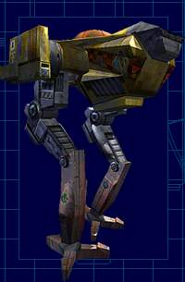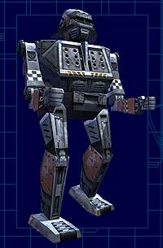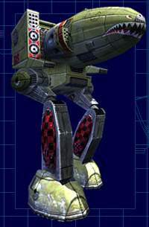

Individual 'Mechs

Want the details? Following, in alphabetical order, are descriptions of all the 'Mechs available in Multiplayer BattleTech: 3025.

Weapon Abbreviation Key
Flamer | FL |  | Short Range Missile 2 | SRM2
Small Laser | SL |  | Short Range Missile 4 | SRM4
Medium Laser | ML |  | Short Range Missile 6 | SRM6
Large Laser | LL |  | Long Range Missile 5 | LRM5
Particle Projection Cannon | PPC |  | Long Range Missile 10 | LRM10
Machine Gun | MG |  | Long Range Missile 15 | LRM15
Autocannon 2 | AC2 |  | Long Range Missile 20 | LRM20
Autocannnon 5 | AC5
Autocannon 10 | AC10
Autocannon 20 | AC20

Assassin ASN-101
Class: Medium
Armor Points: 67
Heat Sinks: 10
Jump Jets: 5
ML
3xSL
SRM2(50)
LRM5(24)

Assassin ASN-21
Class: Medium
Armor Points: 76
Heat Sinks: 10
Jump Jets: 7
ML
SRM2(50)
LRM5(24)

Atlas AS7-D
Class: Assault
Armor Points: 275
Heat Sinks: 20
Jump Jets: 0
AC20(10)
LRM20(12)
SRM6(15)
2xML
2xML*

Banshee BNC-3E
Class: Assault
Armor Points: 218
Heat Sinks: 16
Jump Jets: 0
PPC
AC5(20)
SL

Banshee BNC-3M
Class: Assault
Armor Points: 218
Heat Sinks: 16
Jump Jets: 0
2xPPC
2xML
SL

Banshee BNC-3Q
Class: Assault
Armor Points: 218
Heat Sinks: 12
Jump Jets: 0
AC20(30)
SL

Banshee BNC-3S
Class: Assault
Armor Points: 218
Heat Sinks: 21
Jump Jets: 0
2xPPC
AC10(20)
SRM6(15)
4xML
2xSL

Blackjack BJ-1
Class: Medium
Armor Points: 136
Heat Sinks: 11
Jump Jets: 4
2xAC2(45)
4xML

Blackjack BJ-1DB
Class: Medium
Armor Points: 122
Heat Sinks: 17
Jump Jets: 4
2xLL
2xML

Blackjack BJ-1DC
Class: Medium
Armor Points: 136
Heat Sinks: 12
Jump Jets: 0
2xAC2(45)
4xML
2xSL

Catapult CPLT-A1
Class: Heavy
Armor Points: 186
Heat Sinks: 15
Jump Jets: 4
2xLRM15(32)

Catapult CPLT-C1
Class: Heavy
Armor Points: 154
Heat Sinks: 15
Jump Jets: 4
2xLRM15(16)
4xML

Catapult CPLT-C4
Class: Heavy
Armor Points: 154
Heat Sinks: 10
Jump Jets: 4
2xLRM20(24)
2xSL

Catapult CPLT-K2
Class: Heavy
Armor Points: 170
Heat Sinks: 20
Jump Jets: 0
2xPPC
2xML
2xMG(200)

Centurion CN9-A
Class: Medium
Armor Points: 136
Heat Sinks: 10
Jump Jets: 0
AC10(20)
ML
LRM10(24)
ML*

Centurion CN9-AH
Class: Medium
Armor Points: 136
Heat Sinks: 10
Jump Jets: 0
AC20(10)
LRM10(24)

Centurion CN9-AL
Class: Medium
Armor Points: 164
Heat Sinks: 16
Jump Jets: 0
LL
ML
SL
LRM10(24)
ML*

Centurion CN9-YLW
Class: Medium
Armor Points: 138
Heat Sinks: 10
Jump Jets: 0
ML
AC20(15)
ML*

Cicada CDA-2A
Class: Medium
Armor Points: 71
Heat Sinks: 10
Jump Jets: 0
2xML
SL

Cicada CDA-2B
Class: Medium
Armor Points: 62
Heat Sinks: 10
Jump Jets: 0
2xML
FL

Cicada CDA-3C
Class: Medium
Armor Points: 71
Heat Sinks: 11
Jump Jets: 0
PPC
2xMG(200)

Commando COM-2D
Class: Light
Armor Points: 68
Heat Sinks: 10
Jump Jets: 0
ML
SRM6(15)
SRM4(25)

Commando COM-3A
Class: Light
Armor Points: 50
Heat Sinks: 10
Jump Jets: 0
ML
2xSRM6(15)
FL

Commando
COM-4D *
Class: Light
Armor Points:
106
Heat Sinks: 12
Jump Jets: 0
2xML
SRM6(15)

* Veteran's Note: the 4D is a special
'trainer' 'Mech designed for new recruits.

Enforcer ENF-4R
Class: Medium
Armor Points: 139
Heat Sinks: 12
Jump Jets: 4
AC10(10)
LL
SL

Grasshopper GHR-5H
Class: Heavy
Armor Points: 196
Heat Sinks: 22
Jump Jets: 4
LL
4xML
LRM5(24)

Hunchback HBK-4G
Class: Medium
Armor Points: 152
Heat Sinks: 13
Jump Jets: 0
AC20(10)
2xML
SL

Hunchback HBK-4H
Class: Medium
Armor Points: 152
Heat Sinks: 13
Jump Jets: 0
AC10(20)
4xML
SL

Hunchback HBK-4J
Class: Medium
Armor Points: 152
Heat Sinks: 14
Jump Jets: 0
5xML
SL
2xLRM10(24)

Hunchback HBK-4N
Class: Medium
Armor Points: 152
Heat Sinks: 13
Jump Jets: 0
AC5(20)
4xML
SL
2xLRM5(24)

Hunchback HBK-4P
Class: Medium
Armor Points: 152
Heat Sinks: 23
Jump Jets: 0
8xML
SL

Hunchback HBK-4SP
Class: Medium
Armor Points: 152
Heat Sinks: 19
Jump Jets: 0
4xML
SL
2xSRM6(30)

JagerMech JM6-A
Class: Heavy
Armor Points: 126
Heat Sinks: 10
Jump Jets: 0
2xAC2(45)
2xLRM15(16)
2xML

JagerMech JM6-S
Class: Heavy
Armor Points: 98
Heat Sinks: 10
Jump Jets: 0
2xAC5(40)
2xAC2(45)
2xML

Javelin JVN-10F
Class: Light
Armor Points: 95
Heat Sinks: 12
Jump Jets: 6
4xML

Javelin JVN-10N
Class: Light
Armor Points: 68
Heat Sinks: 10
Jump Jets: 6
2xSRM6(30)

Jenner JR7-D
Class: Light
Armor Points: 68
Heat Sinks: 10
Jump Jets: 5
4xML
SRM4(25)

Jenner JR7-F
Class: Light
Armor Points: 111
Heat Sinks: 10
Jump Jets: 5
4xML

Orion ON1-K
Class: Heavy
Armor Points: 213
Heat Sinks: 10
Jump Jets: 0
AC10(20)
LRM15(16)
SRM4(25)
2xML

Orion ON1-V
Class: Heavy
Armor Points: 170
Heat Sinks: 10
Jump Jets: 0
AC10(20)
LRM15(16)
2xSRM4(50)
2xML

Orion ON1-VA
Class: Heavy
Armor Points: 213
Heat Sinks: 16
Jump Jets: 0
AC10(20)
2xSRM4(50)
2xML

Panther PNT-9R
Class: Light
Armor Points: 108
Heat Sinks: 13
Jump Jets: 4
PPC
SRM4(25)

Quickdraw QKD-4G
Class: Heavy
Armor Points: 129
Heat Sinks: 13
Jump Jets: 5
2xML
LRM10(12)
SRM4(25)
2xML*

Quickdraw QKD-4H
Class: Heavy
Armor Points: 129
Heat Sinks: 13
Jump Jets: 5
4xML
LRM10(12)
SRM4*(25)

Quickdraw QKD-5A
Class: Heavy
Armor Points: 129
Heat Sinks: 17
Jump Jets: 5
SRM4(25)
4xML
2xML*

Raven RVN-1X *
Class: Light
Armor Points: 68
Heat Sinks: 11
Jump Jets: 0
4xML
SRM6(15)
LRM10(12)

* Veteran's Note: The Raven is a Liao prototype,
specially re-fitted for combat duty.

Spider SDR-5D
Class: Light
Armor Points: 60
Heat Sinks: 10
Jump Jets: 8
ML
FL

Spider SDR-5K
Class: Light
Armor Points: 60
Heat Sinks: 10
Jump Jets: 6
ML
2xMG(200)

Spider SDR-5V
Class: Light
Armor Points: 60
Heat Sinks: 10
Jump Jets: 8
2xML

Stalker STK-3F
Class: Assault
Armor Points: 198
Heat Sinks: 20
Jump Jets: 0
2xLL
4xML
2xLRM10(24)
2xSRM6(30)

Stalker STK-3H
Class: Assault
Armor Points: 198
Heat Sinks: 20
Jump Jets: 0
2xLRM20(12)
2xSRM6(30)
4xML

Stalker STK-4N
Class: Assault
Armor Points: 198
Heat Sinks: 26
Jump Jets: 0
2xLL
4xML
LRM10(12)
2xSRM6(30)

Trebuchet TBT-5J
Class: Medium
Armor Points: 124
Heat Sinks: 15
Jump Jets: 5
3xML
LRM15(8)

Trebuchet TBT-5N
Class: Medium
Armor Points: 116
Heat Sinks: 10
Jump Jets: 0
3xML
2xLRM15(16)

Trebuchet TBT-5S
Class: Medium
Armor Points: 116
Heat Sinks: 18
Jump Jets: 0
3xML
2xSRM6(30)

Trebuchet TBT-7K
Class: Medium
Armor Points: 116
Heat Sinks: 11
Jump Jets: 0
PPC
AC5(20)
SRM2(50)

UrbanMech

UM-R60
Class: Light
Armor Points: 103
Heat Sinks: 11
Jump Jets: 2
AC10(10)
SL

UrbanMech

UM-R60L
Class: Light
Armor Points: 68
Heat Sinks: 11
Jump Jets: 2
AC20(5)
SL

Vindicator VND-1AA
Class: Medium
Armor Points: 74
Heat Sinks: 16
Jump Jets: 5
PPC
ML
SL
LRM5(24)

Vindicator VND-1R
Class: Medium
Armor Points: 144
Heat Sinks: 16
Jump Jets: 4
PPC
ML
SL
LRM5(24)

Vulcan VL-2T
Class: Medium
Armor Points: 86
Heat Sinks: 10
Jump Jets: 6
AC2(45)
ML
FL
MG(200)

Vulcan VL-5T
Class: Medium
Armor Points: 115
Heat Sinks: 12
Jump Jets: 6
4xML
FL
MG(200)

Weapons

The three major weapon types in Multiplayer BattleTech: 3025 are energy-based, ballistic, and missiles. Energy weapons are powered by your 'Mech's engine, and never run out. Ballistic weapons and missiles require ammunition ammo, which is carried by the ton. These weapons may be fired until your ammo stock is depleted.

Veteran's Note:
Ammunition is flammable! Your supply of missiles or ammo can explode if hit in combat, which will destroy your ammo supply.

Ammo is allocated by weapon type, not by individual weapon. For example, if your 'Mech is equipped with four Autocannon 5's, none of them will fire when you run out of that ammo type.

The number that appears after an Autocannon listing (Autocannon 2, 5, 10 or 20) refers to the amount of damage the Autocannon does per shot. For example, an Autocannon 10 does 10 points of damage.

The number following a missile listing (SRMs or LRMs) indicates the number of missiles per shot. For example, an SRM 4 fires four missiles that do two points of damage each, if they hit. Not all missiles will always hit your target, and not all will hit your target in the same place. Long range missiles (LRMS) do one point of damage per missile hit, but that damage is generally grouped in five-point clusters (five missiles) striking a single area, with each group of five tending to strike a different area. An LRM 10, for example, will generally strike two areas of your target.

Weapon Table Key:
Name the weapon's name.
Heat the amount of heat the weapon generates when fired.
Damage the amount of damage the weapon does on contact.
Delay how many seconds you must wait between shots.
Range the weapon's combat range in meters (hits beyond this range cause no damage).
Ammo the number of shots available per ton of ammunition (- indicates an energy-based weapon).

Weapon Name | Heat | Damage | Delay | Range | Ammo
Flamer | 3 | 2 | 5 | 90 | -
Small Laser (S. Laser) | 1 | 3 | 5 | 90 | -
Medium Laser (M. Laser) | 3 | 5 | 5 | 270 | -
Large Laser (L. Laser) | 8 | 8 | 7 | 450 | -
Particle Projection Cannon (PPC) | 10 | 10 | 10 | 540 | -
Machine Gun (MG) | 0 | 2 | 2 | 90 | 200
Autocannon 2 (AC2) | 1 | 2 | 2 | 720 | 45
Autocannnon 5 (AC5) | 1 | 5 | 5 | 540 | 20
Autocannon 10 (AC10) | 3 | 10 | 5 | 450 | 10
Autocannon 20 (AC20) | 7 | 20 | 7 | 270 | 5
Short Range Missile 2 (SRM2) | 2 | 2 | 5 | 270 | 50
Short Range Missile 4 (SRM4) | 3 | 2 | 5 | 270 | 25
Short Range Missile 6 (SRM6) | 4 | 2 | 5 | 270 | 15
Long Range Missile 5 (LRM5) | 2 | 1 | 7 | 630 | 24
Long Range Missile 10 (LRM10) | 4 | 1 | 7 | 630 | 12
Long Range Missile 15 (LRM15) | 5 | 1 | 7 | 630 | 8
Long Range Missile 20 (LRM20) | 7 | 1 | 7 | 630 | 6

Menu Bar

The Menu Bar along the top of the non-combat screens -- called the top menu bar -- offers a variety of ways to interact with the game, communicate with your friends, manage your options, and get help in Multiplayer BattleTech: 3025. The categories along the bar are:

Game | Community | Options | Help | Find |  | (My Mechs) | (My Stats)
Credits  Exit | Contact List  Ignore List | Controls  Audio  Video  Word Filter | Pilot Training  Show Tutorial  Page Sysop  Report | Find Player  Find Planet

Game
Use this menu to access the Credits screen or to Exit the game.

Credits
Select this option to view the Credits screen for Multiplayer BattleTech: 3025. The game credits are also listed here.

Exit
Ready to leave? Selecting Exit brings up a confirmation dialog; if you're really sure, click Ok to leave the game. All your latest character information (score, wins, losses, etc.) will be automatically saved for the next time you play. If you are not yet ready to leave, clicking Cancel will return you to the game.

You can also exit the game by clicking the X in the rightmost side of the menu bar.

Community
Use this menu to access your Contact List and your Ignore List.

Contact List
Use your Contact List to help keep track of your friends and opponents. To add someone to your list, enter their call sign and click Add; the call sign will appear in the list to the left. To remove someone, select a call sign in the list and click Remove. Click Close to exit this dialog.

There are many ways to use your contact list to help keep in touch with your online friends. Double-clicking a player in your Contact List will open up a dialogue where you can view that player’s pilot record. If your friend is currently in the game, highlighting his or her name and clicking Message will send a flash message. Clicking Go To Player will take you to the planet the highlighted player is currently on, providing it is a planet that you are normally allowed to enter.

Ignore List
Your Ignore List blocks messages from pilots you'd rather not hear from. If someone is annoying you, you may block all his messages by selecting Ignore List from the Community menu and adding that person to your list. Enter their call sign and click Add; the name will appear in your Ignore List to the right. To remove someone, select a call sign in the list and click Remove. Click Close to exit this dialog.

Veteran's Note:
If another pilot is being disruptive, you may also consider filing a complaint.

Options
Use this menu to customize Video, Audio, and Control functions for Multiplayer BattleTech: 3025, and also to create and manage a Word Filter if you wish to prevent certain words from being displayed on your screen. After you finish setting your options, use the buttons on the far right screen to finalize your changes:

Ok -- saves all the current option settings.
<<Back -- leaves the options as they were before entering the Options screens.
Reset -- restores all options on the current screen to the game defaults.

Video Options
Use this dialog to customize the graphic appearance of the game. The standard controls include:

- Detail -- Set to Low, Medium, High or Custom settings. Use the Low setting for maximum game performance on a slower system, or the High setting for maximum graphic detail. By default, the game will select a setting for you that results in the highest detail level without hurting your computer's performance.
- Screen Resolution -- range is from 800x600 to 1600x1200. The default is 800x600. Each resolution setting also includes a rating for color depth, either 16 or 32 bits. Changing to 32-bit depth enhances your color display but may slow game performance, depending on your system speed and the capabilities of your video card.
- Display Adapter -- allows you to choose between all available graphics devices (video cards) on your system. The default is generally your primary display device. (Leave this setting as it is unless you're familiar with all your display devices.)
- Shadow Complexity -- the farthest right position on the slider bar sets maximum shadow complexity.
- Object Complexity -- the farthest right position on the slider bar sets maximum object complexity.
- Far Clip Distance -- moves the far clip plane forward and back, so more distant hills and objects will disappear or appear on the horizon.
- Terrain Detail -- controls the maximum number of polygons used in the depiction of the terrain.
- Terrain Detail Texture -- controls whether or not any texture detail is applied to the terrain.
- Multiple Terrain Textures -- controls whether or not the terrain is displayed using multiple textures simultaneously.
- Gamma Correction -- controls the brightness of the screen.
- Screen Shot Save Location -- allows you to specify the directory on your system that screen shots will be saved to. Either type in the directory address into the box, or click Browse to browse your system directories. The default is:
C:\program files\eacom\mpbt3025.

Audio Options
Use this menu to customize the audio options in the game. Each audio option is repeated for both pre-combat and combat situations. For example, you might set the Sound Effects volume high in combat, but low for pre-combat. The audio options include:

- Sound effects on -- turns sound effects on/off.
- Sound effects volume -- adjusts the volume level of sound effects.
- Music on -- turns the music on/off.
- Music volume -- adjusts the volume level of the music.
- Use custom MP3 directory -- select this box to play music from your own MP3 directory instead of the game's default directory.
- MP3 directory -- if you selected the option to use your personal MP3 directory, use this option to set the location of the MP3 directory on your system.

Control Options
Use this dialog to customize the joystick, mouse and keyboard controls, as well as the basic control options for Multiplayer BattleTech: 3025.

To change any of those controls, highlight the game function in the list of commands that you want to change, and then click the keyboard key or operate the mouse or joystick control that you want to assign that function to.

Veteran's Note:
If you assign a control that was already used by another game function, the replaced function will be highlighted in red to indicate that it needs a new assignment.

For example, if you decided to change the Eject keyboard control from <esc> to E, you'd highlight Eject in the list of controls by clicking on it with the mouse, and then type E. The letter E will now appear next to Eject in the control list.

The right side of the interface lists the basic options for mouse or joystick control. These include:

Mouse
- Sensitivity -- adjusts the motion sensitivity of the mouse.
- Wheel Action -- the drop-down box selects a function for the mouse wheel, if you have one. The choices are: Cycle TICs, Cycle Weapons, Zoom, or Cycle Targets.
- Reverse Y Axis -- reverses the Y-Axis of the mouse.
- X Axis Action -- selects between Turn and Twist. (Default is Turn.)

Stick
- Sensitivity -- adjusts the motion sensitivity of the joystick.
- Use Forward Throttle Only -- disables backward movement on your joystick (you can still move in reverse by using the keyboard control.)
- Reverse Y Axis -- reverses the Y-Axis of the joystick.
- X Axis Action -- selects between Turn and Twist. (Default is Turn.)
- Disable Controllers -- disables all inputs except the mouse and keyboard.

Word Filter
If you don't want certain words to be displayed on your computer while playing Multiplayer BattleTech: 3025, select Word Filter from the Community menu. You’re your Word Filter is active, any word you add to your filter list will be displayed only as comic-style swearing symbols (like: @!*&#%) if it appears in a chat or instant message.

Activate or deactivate your word filter by clicking the check box on the left of the dialog. To add a word to your list, type the word in the box and click Add; that word will appear in the list to the right. To remove a word, select a word in the list and click Remove.

If you wish to password-protect your list (so it cannot be viewed or changed by anyone without the password,) click Set Password. You will need to enter the password twice, and then click Ok. You may also use Set Password to change your current password.

When you're finished adding words and managing your password, click Close to save your changes and exit the dialog.

Help
Use this menu to access Pilot Training, to Show the Screen's Tutorial for each game screen, to Page a Sysop if you need community support, or to File a Report if another player is causing trouble.

Pilot Training
Use this option if you want to review all or any part of Pilot Training. For complete information, see the section about Pilot Training here.

Show This Screen's Tutorial
If you're confused about the purpose any game screen you are viewing, selecting this option displays an information box regarding the function of that screen. This option changes to Hide This Screen's Tutorial once selected. When you're finished reading the information, select the 'Hide Tutorial' option or just click the X in the upper right corner of the information box.

Page a Sysop
If you need system help, select Page Sysop from the Community Menu to send a live message to a system operator. Enter your message in the dialog that appears, and then click Send.

Veteran's Note:
Depending on the number of people asking for help and the number of system operators available, you may have to wait a bit for a response. However, unless you received a message saying that no Sysops were available, you can be sure that one got your message and will respond as soon as possible.

File a Report

If you want to complain about another pilot's offensive behavior, select File Report from the Community menu. A dialog will appear asking for the name of the pilot you wish to complain about and a description of your complaint. Click Send to file your report.
Veteran's Note:
Reports are taken very seriously by the Multiplayer BattleTech: 3025 system operators; therefore, abuse of this feature will result in penalties.

Find
Use this menu if you need to Find a Player or to Find a Planet in a hurry.

Find Player
Use this option to locate, view information on, or chat with another player. Enter his or her call sign in the Find Pilot box, or use the drop-down arrow in the box to display a list of players in your Contact List, and then click Find.

Once you have found a player, other options become available. The View button brings up the View Pilot dialog for that player, displaying level, rank points, points required to attain the next level, and also that player's combat record, including total number of wins, losses, and overall win percentage.

If that player is currently logged into the game, two other options are available. You can click Go To Player, which moves you to that player's location if possible. The Message button opens a dialog to send an instant message. Enter your message in the lower box, then press the Enter key. These buttons are grayed out if that player is not logged in.

On the right side of the dialog, the Add Contact button adds that person to your Contact list, and Ignore Player adds that person to your Ignore List. Click Cancel when you are finished.

You can also bring up this dialog by double-clicking on any pilot's name in the player list that appears in the chat section of the Inner Sphere Map, any Staging Area or Mission Room, or the My 'Mechs screen.

Find Planet
This option brings up an alphabetical list of all the planets in the Inner Sphere. Select any planet in the list and either double-click on the planet name or click Find to highlight that planet in the Inner Sphere Map. This function is useful if you've arranged to meet friends on a specific planet and want to locate it quickly on the map. You may also use this screen if information about a planet has just appeared on the scrolling ComStar Update Ticker and you need to get there in a hurry!

The Find Planet option is unavailable if you have not yet earned your Solaris Graduation Medal.

My 'Mechs

If you wish to review your 'Mech collection or to purchase a new 'Mech to use in combat, click the My 'Mechs button to enter the 'Mech Bay.

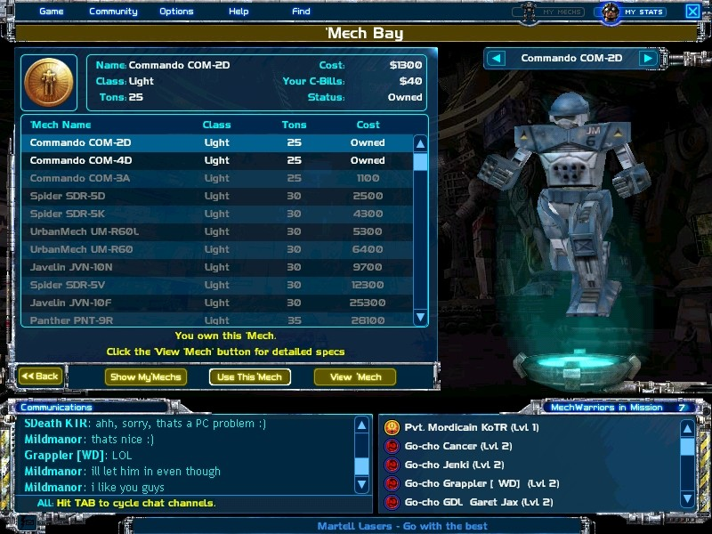

The animating picture on the right depicts the currently selected 'Mech. On the left side of the screen is a list of all the 'Mechs that you currently own. 'Mechs that you own and can fight with on the current planet are listed in white. 'Mechs listed in gray are not allowed on the current planet. If you want to switch 'Mechs before battle, click the name of the eligible 'Mech that you wish to use, or use the right and left arrows over the animating 'Mech to display the eligible 'Mech you want, and then click Use This 'Mech.

Veteran's Note:

Every new pilot starts with a Commando-4D, but that won't get you far. As soon as you earn enough C-bills, you'll probably want to buy a new 'Mech.

To view a complete list of all the 'Mechs in the game, and possibly buy one to use in an upcoming battle, click Show All 'Mechs. (When clicked, this button changes to Show My 'Mechs in case you wish to return to your own list.) Use the right and left arrows above the animating 'Mech to cycle through the 'Mech types, or click on a name in the list to bring up basic information for that particular 'Mech. In this screen, 'Mechs listed in white are already owned by you; 'Mechs listed in gray are ones you either are not qualified for, can't afford, or are not allowed on the current planet; and 'Mechs listed in green are ones you can afford, are qualified for, and are allowed on the planet.

Veteran's Note:

Once you buy a 'Mech, it's yours. You can't change your mind and sell it again. Carefully check each 'Mechs load out before purchase.

For more extensive information about the weapons, armor and capabilities of a selected 'Mech, click View 'Mech. Next to the 'Mech illustration you'll now see a list of that 'Mech's available armaments, a chart illustrating the armor levels on the various parts of the 'Mech, and information regarding Tonnage, Cruising Speed, Max Speed, Heat Sinks, Jump Jets, Cost and your available C-bills.

Move your mouse over any weapon in the weapon list to display complete information about that weapon, including: a brief description, the weapon's pros and cons, damage rating, range, heat, and delay. Clicking <<Back returns you to the previous screen.

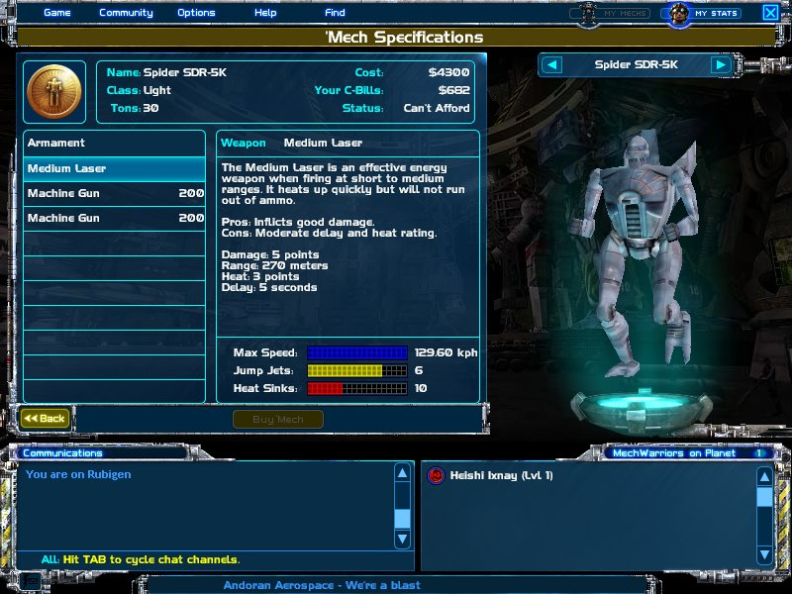

When you select a 'Mech that you like, are qualified to pilot and can afford, click the Buy 'Mech button in the View All 'Mechs screen to add that 'Mech to your collection. The C-Bills will be withdrawn from your account and your new 'Mech will immediately become available for battle.

Click the <<Back button anytime to return to the previous screen.

My Stats

Clicking My Stats brings up a dialog displaying your rank, call sign, House, the planet you are currently on, level, rank points, points required to reach the next level, daily salary, and C-bills. It also shows your combat record: total number of wins, total losses, and win percentage. Total House Territories is the number of planets currently controlled by your House, and Total House Econ Value shows the total value of those planets.

At the bottom of the dialog, you'll see a row of medals indicating which 'Mech weight classes you are qualified to pilot. A new pilot will only have a Light 'Mech medal. You'll earn your Medium Class medal at Level 8, your Heavy Class medal at Level 21, and your Assault Class medal at Level 30.

You can use this dialog to change your House allegiance, create a new character, visit the 'Mech Bay, or access Pilot Training:

To defect from your House and ally yourself with a new one, click Change House. Select the name of the House you want to join, then click Done. You can only change Houses once every 24 hours. This option is grayed out if you are a new player on Solaris and have not yet chosen a House. Warning: choosing this option will demote your character and cut your total C-bills in half. Once changed, these things cannot be returned to you.

To create a new character, click New Character. You will be asked to enter a new call sign and then choose a new House, much like if you were entering the game for the first time. This option is grayed out if you are a new player still restricted to Solaris. Warning: choosing this option will reset your current character, permanently erasing your score, C-bills and any 'Mechs you currently own. Once erased, these things cannot be returned to you.

To access any of the Pilot Training scenarios, click Pilot Training.

You can also bring up the My Stats screen by double-clicking on your pilot's name in the player list next to any chat window.

Credits

KESMAI STUDIOS
Project Management
Executive Producers Al Roireau
Arnold Hendrick
Producers Nick Laiacona
Dave Marsh
Associate Producers Brian Peters
Josh Davis
Andrew Boyd
Assistant Producers Ben Heckel
Jon Schweitzer

Game Design Nick Laiacona
BattleTech Team
Tony Van
Joe Balshone

BattleTech Programming
Lead Programmer Damon “Vorpal” Osgood
Programmers Colin “Lokist” Shannon
Ed "Whitehead" Teffeau
Robert "MadCow" Haschart
Matt "HazMatt" Shaw
Randy “DevNull” Eichman
Geoffrey “infraction” Lay
Chris “Thack” Thacker
Tony “Boot” Wetmore
Tim “Vulture” Ballew

Additional Programming
John “Tenser” Wells
John Sizemore
Jon Moore
Doug “MacDuff” Sutherland
Matt Monas
Kelton Flinn

Art and Audio
Art Director Bob Frizzell
Technical Art Director Jeff “Quarters” Hanna
Lead 2D and 3D Artist Greg “Reapin' Wombat” Grimsby
3D Artists Xavier Ojeda
2D Artists Rich Sisson
Jeff Hanna
3D Modeling Frank Williamson
Additional Art Nick Brunstein
Sound and Music Brad Derrick
Voice Talent Tynley Bean

K3D Engine
Producer Forrest Workman
Lead 3D Programmer Matt Shaw
3D Programmers Robert Haschart
Kelton Flinn
Paul Suggs
Charles Pitzer
Technical Art Director Jeff Hanna

Associate Producer Andrew Boyd
Assistant Producer Kris Moon
QA Lead Jack Greaves

ARIES Multiplayer Game Technologies
Richard Brewster
Ariel Butler
David Compton
Randy Eichman
Louis Foster
Dave Goldstein
Allen Gooch
Matt Monas
Ketan Parekh
Kevin Snead
Paul Suggs
Matt Thomas
John Wells
Ed Zavada

Customer Support and QA
Customer Support Lead Jason Hurt
QA Lead Kent Peterson
QA Manager Jay Piette
Testers
Mark Ball Sean Bean
Rafael Chandler Matthew Cooney
Thomas Cruz Rob Frye
Mark Goldstein Jack Greaves
Joel Hansen Henry Huang
Matt Jacobs Amanda Kahle
Lincoln Lilley Darren Manes
Joe Maris Phil McCarty
Ray McDaniel Giles McDonald
Dave Munn Doug Noel
Peter O'Leary Liam O'Rourke
Randy Pratt Chris Rollins
David Rose Kyle Stewart
Dave Talbott Ted Tarrant
Stuart Templeton Sean Thomas
Tosh Toida Stefan Trefil
Terry White Matt Whited

EA.COM WORLDS TEAM
Senior Producer Tony Van
Associate Producer David Gray
Network Producer Robert Lew
Technical Director Steve Gray
Operations Architect Kevin Kwast
Operations David Nejely
Marketing Jefferson Dong
Web Coding Michael Chernobrod
Florence Wong
Community Lead Scott McDaniel
Director of Community Matt Callaway

Testers Joe Adams Bryan Brown
Phillip Cohen Doug Doine
Steve Fleming Francisco Gomez
Jaime Gonzales Darren Hooper
Greg McCord Saul Montes
Chad Norket Andy O'Brien
Micah Saul Nathan Shugart
Jesse Waco Calvin Wong
Andy Young

Manual
Rhonda Van

Special Thanks
John Taylor Roger Bickerstaff
Ron Patterson Chris McKibbin
John Riccitiello Jon Kimmich
Allen Rees Adrianne Canfil
Angelo Nunes Ken Sayler
Jason Hurt Teri Marsh
Monika Peters Joanne Shannon
Racheal Grimsby Alex Bollie
Lynn Osgood Kari Teffeau
Stephanie Guerlain Chris Plummer
Luc Barthelet Brett Downen
Stan Quinn Vikash Shaw
Traci Snoddy Leah Dansby-Ezeoha
Steve Bene Lisa Tensfeldt
Brian Neider Sue Garfield
Joe Keene John P. Logsdon
Bert Colley Hui Guo
Mark Wallace Subramani Krishnamurthi
Chad Okada Craig Alexander
Henry Perkins Warren Mayoss
Andrew Magruder Marc Saint-Pierre
Alison Wong Steve Rish
Jeanne Owens Jill Nimmo
Tim Bell Joel Linzner
Tom Nichols Jack Heistand
Jennifer Damewood Karen Jenkins
ComStar members MPBT Solaris players
House leaders Molo
Mr. Peterson Spot the BattleTech mascot!

Copyright Notice
BattleTech material © 2001 WizKids LLC. MechWarrior, BattleTech, BattleMech, and 'Mech are registered trademarks or trademarks of WizKids LLC and Microsoft Corporation in the United States and/or other countries. All Rights Reserved. Used under license by Kesmai Studios. Kesmai Studios is a trademark or registered trademark of EA.com in the U.S. and/or other countries. Some material © 2001 EA.com Inc. All rights reserved. All other trademarks are the property of their respective holders.

